12/19/2017

STA 9700 Final Project

ID 23709543

Image by Sylvain Sonnet/Photographer's Choice RF/Getty Images. Link: https://www.thebalance.com/technical-analysis-your-advantage-in-the-stock-market-3140459

Regression Analysis on Stock Daily Risk Range

Yang Jin



Table of Contents

Chapter 1. Introduction 3

1. Topic 3
2. Data Source 3
3. Variables 3
4. Data View 4

Chapter 2. Simple Linear Regression 5

1. Scatterplot 5
2. Visual Analysis of Scatterplot 5
3. The linear Regression Model 6
4. Software Output for the Fitted Model 7
5. Analysis of Output 8

Chapter 3. Matrix Methods 9

1. Simple Linear Regression in Matrix Terms 9
2. Multiple Linear Regression in Matrix Terms 12

Chapter 4. Polynomial Regression 14

1. Simple Polynomial Regression 14
2. Multiple Regression with a Dummy Variable and an Interaction Term 18

Chapter 5. Model Selection 22

1. Best Subsets Model Selection 22
2. Forward Stepwise Model Selection 29
3. Variance Inflation 29
4. The Press Residuals 30
5. Cook’s D 32

Chapter 6. Analysis of a Fitted Model 32

1. Analysis of Output 33
2. R-square 34
3. Adjusted R-square 34
4. The Partial Regression Coefficients 35
5. Model Diagnostics 37

Chapter 7. Models for Autocorrelation 38

1. Handling Random Walks 38
2. The First-Order Autoregressive Model 38
3. The Durbin-Watson Test 38
4. Test Model on Data 39

**Chapter 1. Introduction**

1. Topic

In this study, we did a regression on 4 years of stock price data on a randomly selected stock. We use the data from the past 9 days to estimate the data of day 10. The purpose of the study is trying to find out a statistical relationship of each day’s daily risk range of this randomly selected stock.

In long term, we want to find out how to estimate the price of a stock from the past historical data we have.

1. Data Source

All the data are downloaded from yahoo finance. (<https://finance.yahoo.com/)>

Here, the random selected stock is named Nordstrom, Inc. (JWN).

Historical prices are collected on a daily basis for JWN, from Sep 12, 2011 to Sep 15, 2017.

1. Variables

From the original data, several columns of data are included. Here, the ‘High’ and ‘Low’ will be used to compute the value of risk range. The variables used for regression are defined as the risk range of the daily stock data, which is defined as daily ‘High’ minus ‘Low’.

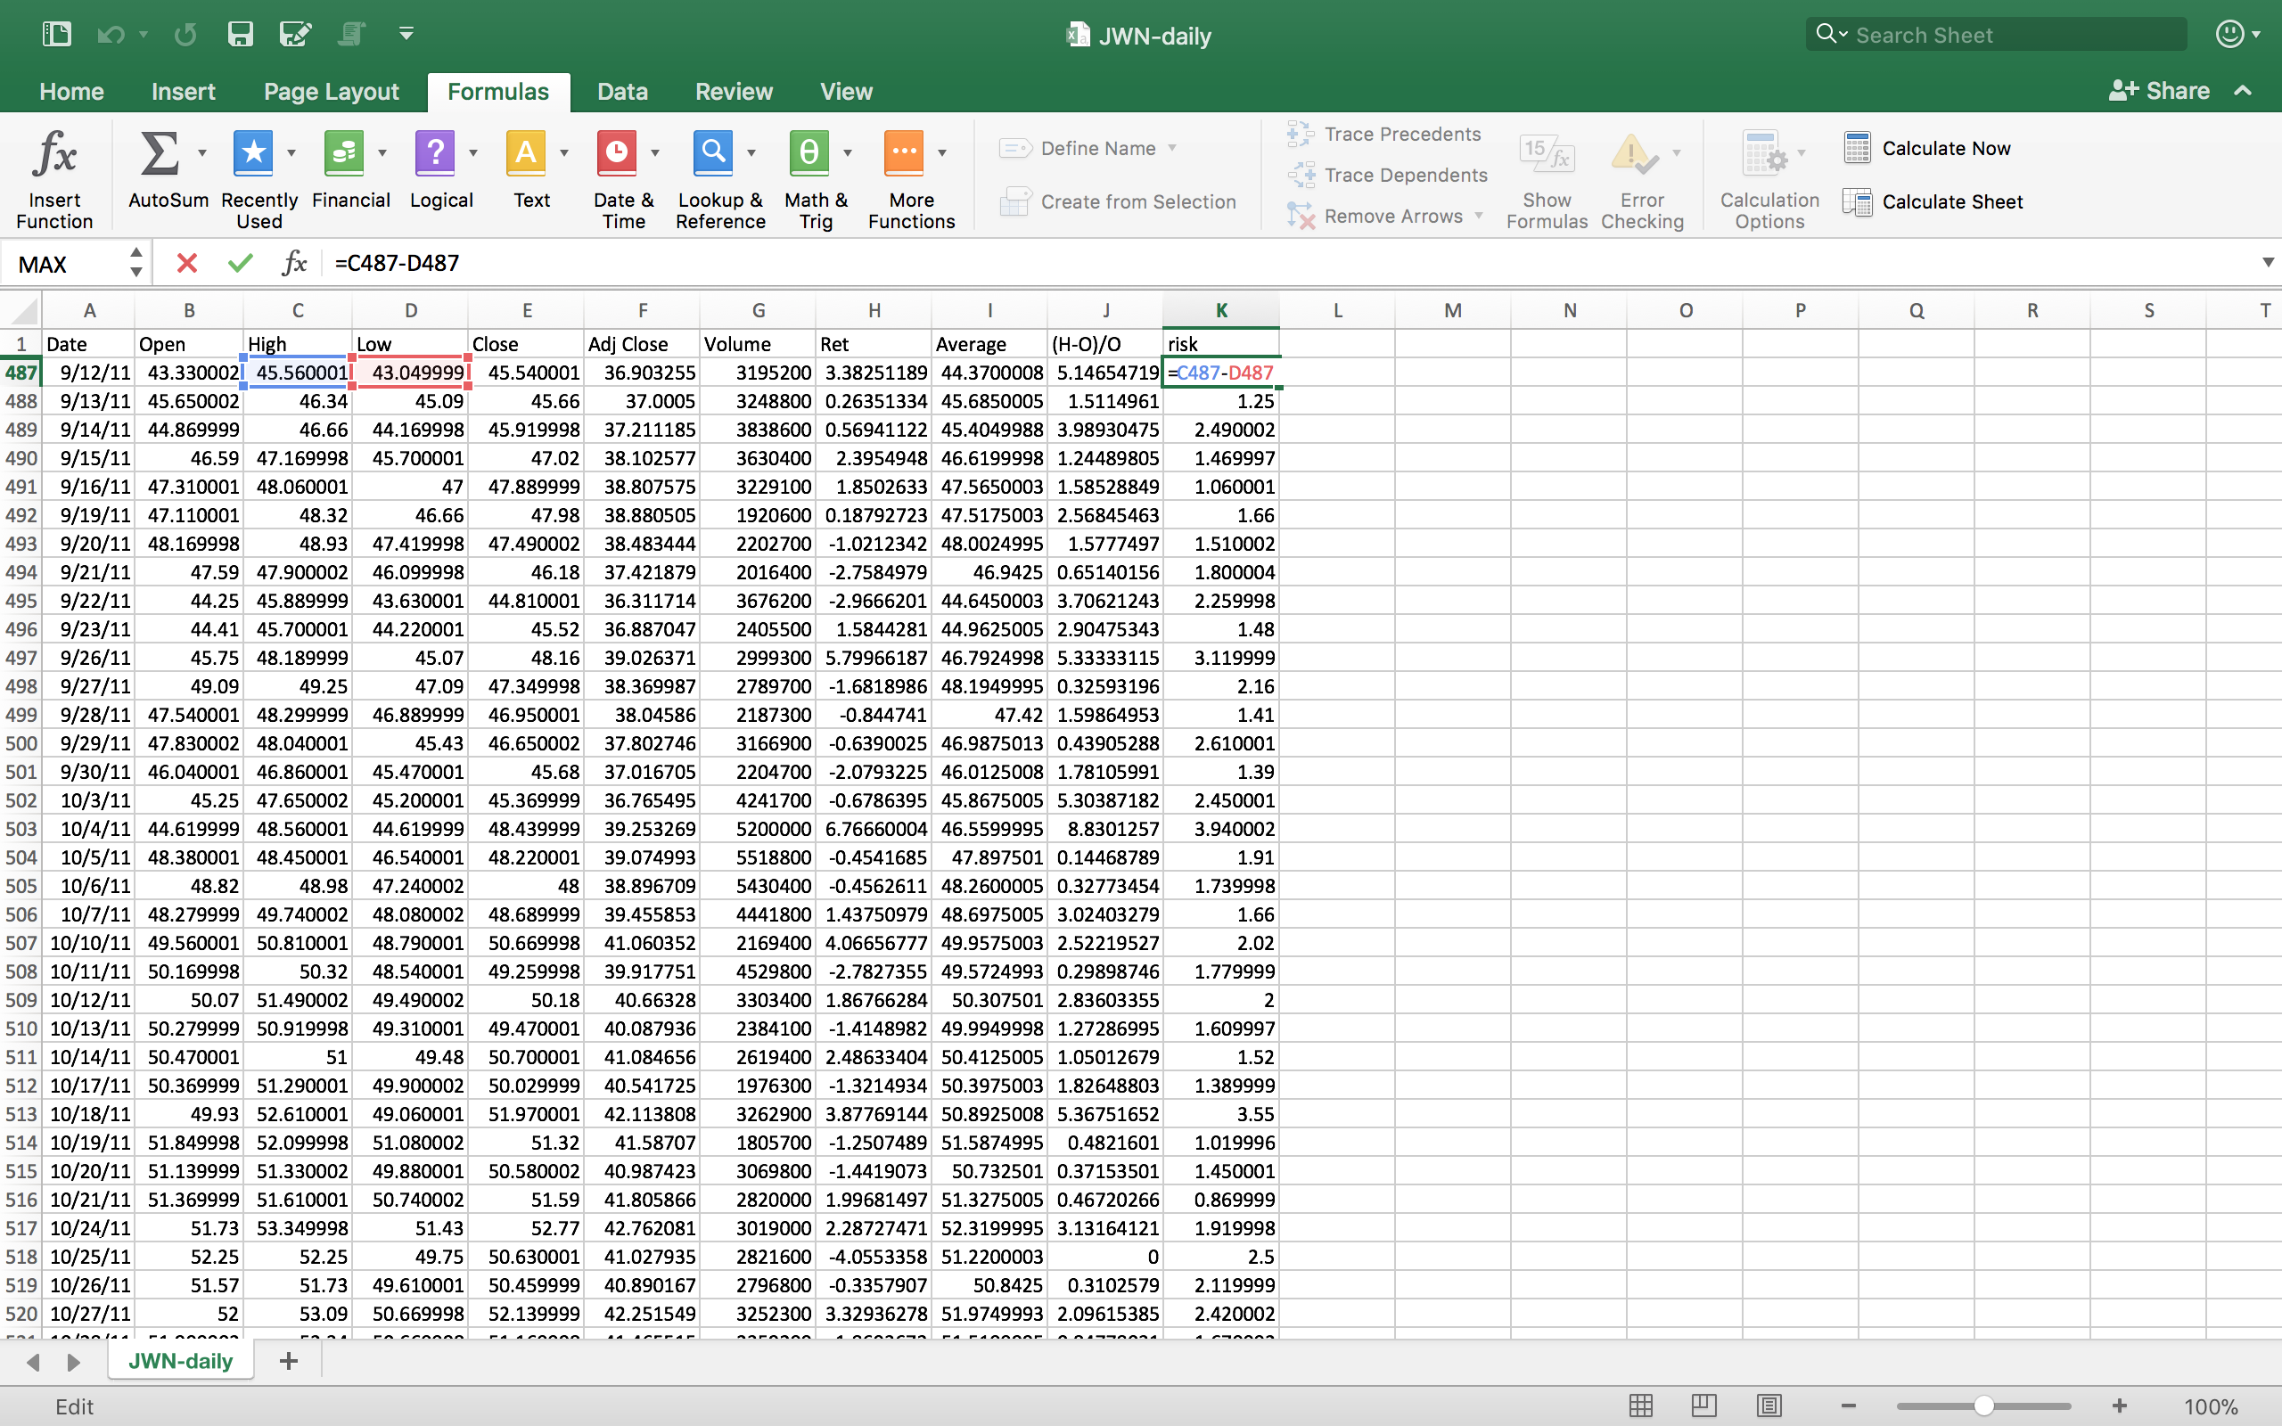

Then, this range is computed for all dates and there are about 1500 observations for each variable. After getting the risk range, other data is not needed in this project and removed from the data table. This risk range column will be our first variable.

Now, we need more variables. We do it in a ‘lag’ date way. For the second variable, we copy the same data as our first variable, and then we delete the first row of it. So, the first variable starts from Sep. 12th and the second variable has the data starts from Sep. 13th. This is our ‘lag’ one day variable. We repeat the same process for 9 times, copy the previous line and then delete the first row. Finally, we get 9 ‘lag’ date variables, from lag 1 to lag 9 plus the original data.

It is not easy to remember things all in a ‘lag’ way. So we did some changes on the variables name. Our original data which starts from Sep 12th will be called ‘day 1’. The lag 1 data starting from Sep. 13th will be day 2. We did same transformation on the variable name until lag 9, which is day 10 now.



In this way, we get 10 variables. If we take a close look at each line, we could understand what every column means. For example, the first cell in the first column is the risk range on 12th, the first cell in the second column is the risk range on 13th, and the first cell in the second column is the risk range on 14th, etc.

We has 10 days’ risk ranges in each line. Day 1 is the oldest date’s risk range data and Day 10 is the most recent date’s data.

1. Data View



**Chapter 2. Simple Regression Model**

Variable ‘Day 10’ will be the y variable, and variable ‘Day 9’ will be x variable here.

Day 10 has the most current data, so we want to see the result when we use the past 9 days’ data to predict the most recent data.

1. Scatterplots

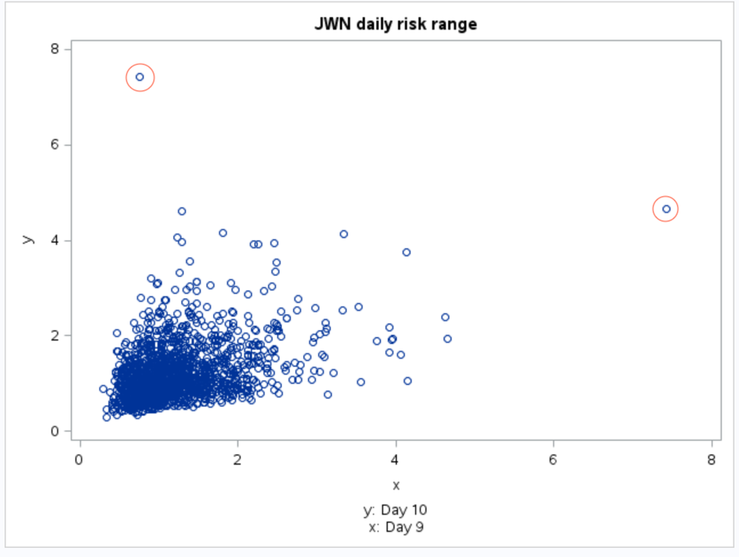

1. Analysis of Scatterplot

The model assumed the distribution of the residuals will be normal distribution and centered at 0.

In the graph above, the heteroscedasticity is very obvious. If there is no heteroscedasticity in our model, it assumes our model has the same population variances for each certain x level. So the software assumes our sample having same variance at every x level. However, when x is close to 0, the variance is small, and the points are dense. When x becomes larger, if we put a vertical cut, we can see the variance become bigger.

There is no obvious curvature inside the model.

There are two points stay way out of the main population. These two points are outliers, which are the points not following the trend of the rest of the data. Leverage points have strong impact on the yhat line of the model. Their changes will largely affect the slope of the line. For these two outliers, they might be also leverage points, depending on their influence on the sample slope. Influential points are the points can strongly influence the sample slope if they are deleted from the data sets. If deleting those two outliers will largely change our sample slope, they will also be influential points.

1. The Linear Regression Model

(a).

The model we use here is a simple linear regression model.

Y|x = β0 + β1x+ ε.

The Y|x inside our model indicates the population average of the subpopulation Y when a x value is given. In our model, we hope if we know the risk range of one day (x), then we can estimate the (population) average risk range of the day after (y).

We call the difference between observed values and estimators, ε. We hope the errors, ε, have a normal distribution and centered on 0, so that the more data we have, the more precise our model will be. For β0, β1, they are based on the similar ideas. Our stock data only cover part of all the historical data. If the complete population, we might get the real value of β0 and β1, but for the limitation of our data sets. We can only get estimated values for β0, β1. We hope the methods we get them can also become more precise as we use more data. We want our estimators are unbiased.

(b). With unbiased requirement, we need to test whether our model is unbiased or not.

The $\hat{y}$ model we used to estimate Y|x is  = b0 + b1xi, which ei = yi - ., . The method we use to get these estimators are called Least Squares Estimation. This method provides the estimators the following properties: E(b1) = β1 and E(b0) = β0. The way we make sure the $\hat{y}$ model we use can reach the regression model Y|x = β0 + β1x+ ε is to ensure the expected values of $\hat{y}$ will be same as real subpopulation average.

So the expected value of , E() = E(b0 + b1xi) = E(b0) + E(b1) xi. Using the properties we get b0 and b1, we can get E()=β0 + β1 xi . Finally, we can get E()=β0 + β1 xi =β0 + β1 xi . For every given x, E()=Y|x. The ei  here represent the difference between the estimator  and the observed values yi.

(c). To compute estimates of β0 and β1 in the model:

Y|x = β0 + β1x + ε.

We use the least squares method which consists of finding estimates of β0 and β1 that minimize Q, the sum of squared deviations,

Q(β0,β1) = .

So we want to get the β0 , β1 to minimize the Q, which is also the population variance V(Y|x).

1. SAS Output for the Fitted Model

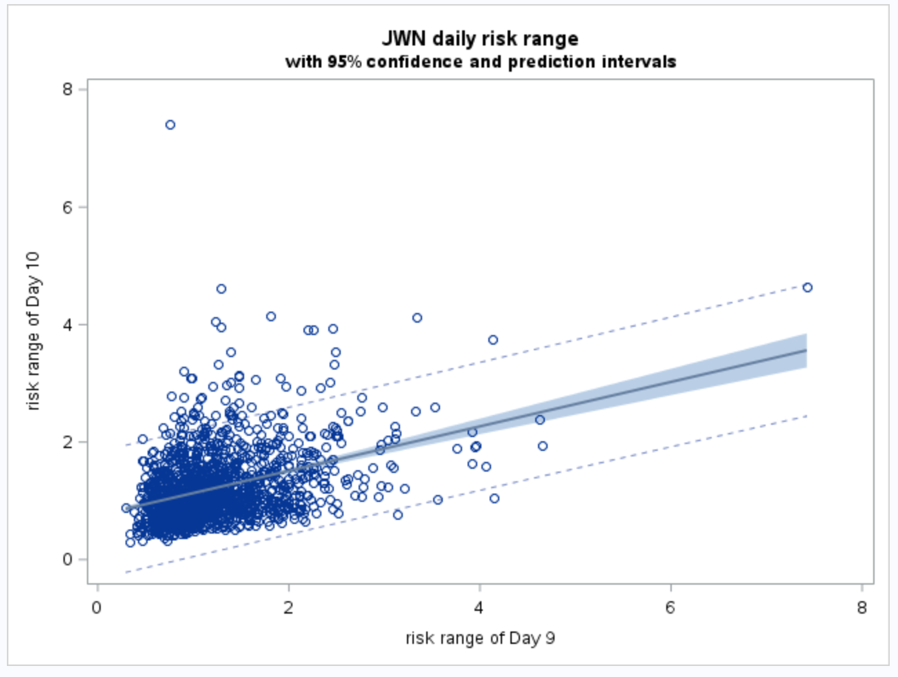

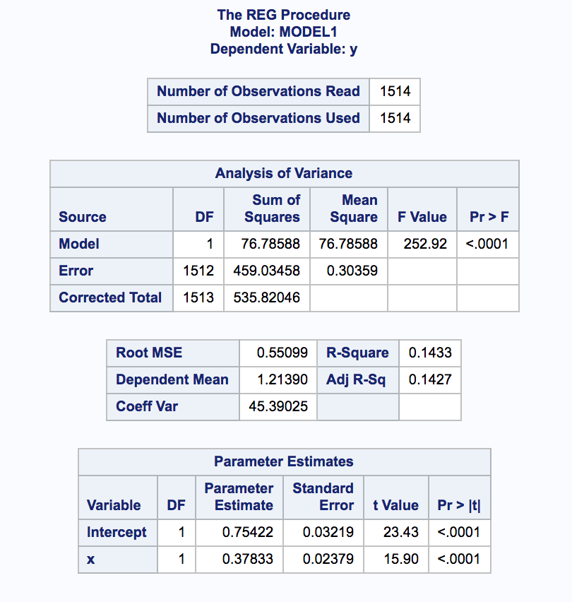

1. Analysis of output
2. The t-tests

In the last table in the graph above, both intercept and parameter are being tested. The regression model we use is  = b0 + b1xi. Now we want to make sure that the b1 we get is obviously different from 0, which indicates our sample slope is large enough to consider there is a regression relationship between x and y. The result of t-test is less the 0.05 which means we reject the null hypothesis: b1 is equal to 0. It turns out our sample slope is different from 0.

The complete population contains more samples than we used in our model. Every subsample contains many observations, and each of them has their sample slope. We can collect all these slopes and they become a daughter population. This daughter population has its own distribution. Then we estimate the mean of this daughter population base on the assumption that it is center at 0.

After that, we get our estimated distribution. We compare our sample slope to our estimated population distribution. Then, we found that our sample slope is an outlier toward our estimated population distribution. So we know our assumption might not be right and our sample slope is not from a distribution that centered at 0. The b1 we get is obviously different from 0.

1. The $\hat{y}$-equation

 = -0.75422 + 0.37833*xi.

Each $\hat{y}$ we get from our model use only part of the complete population. The data we covered in our sample have only part of all actual dates’ price data. If we use more data, we will get more precise $\hat{y}$. Each $\hat{y}$ has its errors and the distribution of errors are different. Then, if we get all the $\hat{y}$ covering all the data in the parent population, we will a $\hat{y}$ daughter population. And the distribution of this daughter population will center at E(Y|x).

1. 95% confidence band & 95% prediction band

Each of sub-samples will generate its own 95% confidence interval for yi. Thus, we can create a "grand-daughter" population of 95% confidence intervals. Some of those intervals will contain yi and some will not. It is our intention that 95% of the intervals in that grand-daughter population will contain yi.

The 95% prediction interval is given a range of values in which it is reasonable to think that next yi , the next Day 10’s JWN risk range will fall if we have the same value of Day 9.



**Chapter 3. Matrix Methods**

1. Simple Linear Regression in Matrix Terms

In this part, the matrix approach to do a simple linear regression of y on x for just one of x-variables. A modest subset of 8 rows are used.

(a). X matrix



(b). y-vector



(c).

 = '

H =(')-1 '





 





(d).

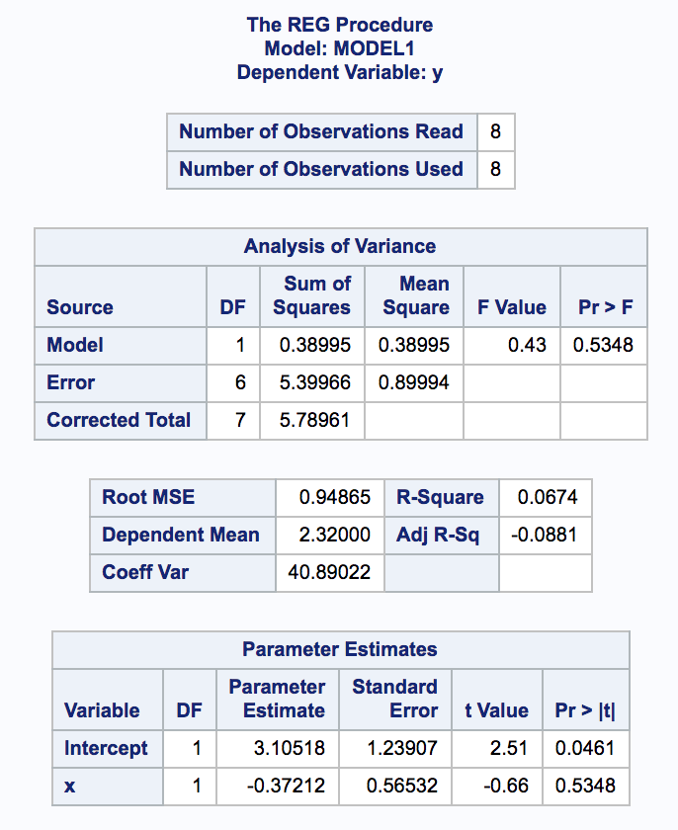

(e).



= 1/8 + (1.48 – (2.109999875)) $\frac{x_{3}-\overline{x}}{SSX}$

*

=1/8+(-0.629999875)*( 3.119999-(2.109999875))/SSX

=1/8 +(-0.629999875)* 1.009999125/2.81599906

= -0.100958642

1. Multiple Linear Regression in Matrix Terms

(a). The new X matrix:

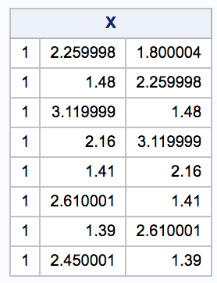

(b). SAS Proc IML is used to fit a model for this subset of data.

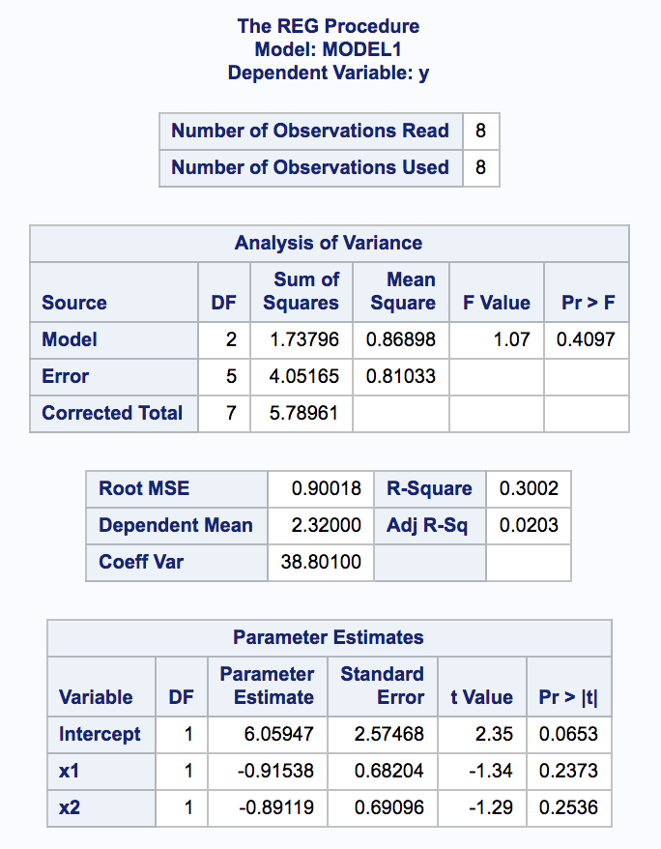

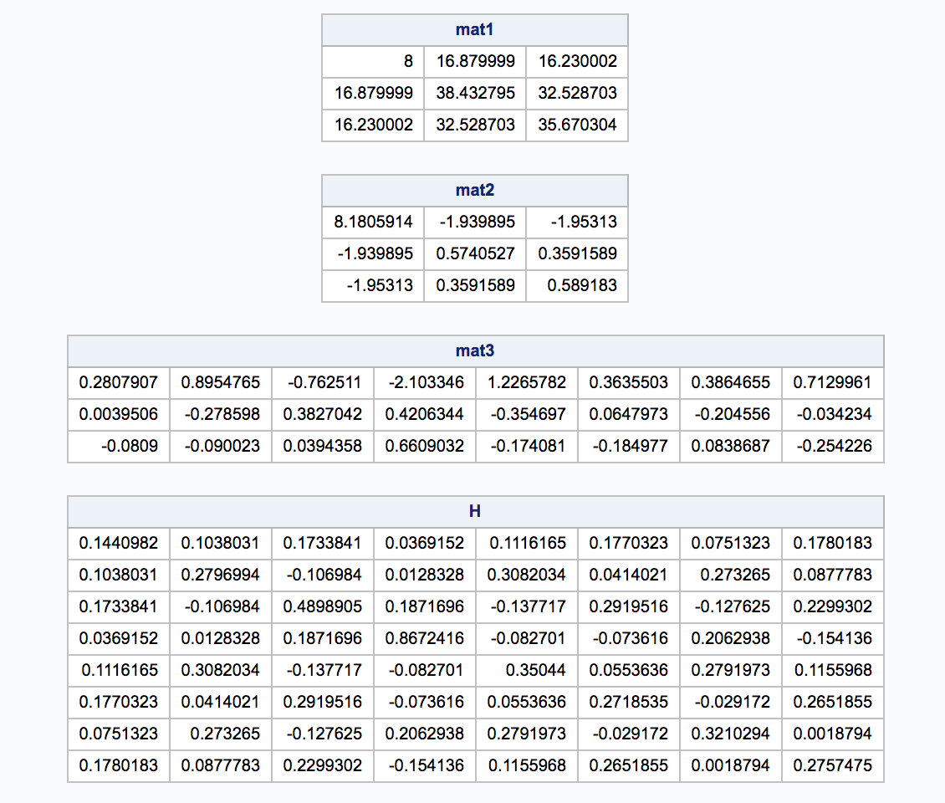

(c). The results from matrix methods and software match.

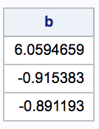

(d). The SAS code used to apply the matrix method is shown in below:

**data** yangjin;

input x2 x1 y;

datalines;

1.800004 2.259998 1.48

2.259998 1.48 3.119999

1.48 3.119999 2.16

3.119999 2.16 1.41

2.16 1.41 2.610001

1.41 2.610001 1.39

2.610001 1.39 2.450001

1.39 2.450001 3.940002

;

**run**;

**proc** **reg**;

model y = x1 x2;

output h=leverage;

**run**;

**proc** **iml**;

use yangjin;

read all;

one_vec=j(**8**,**1**);

X= one_vec || x1 || x2;

print X;

Y= y;

mat1 = t(X) * X;

mat2 = inv(t(X) * X);

mat3 = inv(t(X) * X) * t(X);

H = X*mat3;

print mat1, mat2, mat3, H;

b = inv(t(X) * X) * (t(X)*Y);

print b;

create new var {b_vec};

append from b;

**quit**;

**proc** **print** data=yangjin;

**run**;

**Chapter 4. Polynomial Regression**

1. Simple Polynomial Regression

As an example simple polynomial regression, one of x-variables is selected and regress y on that x-variable and its square. That is, regress *y* on *x* and *x2*, for some selected *x-variable*.

(a). SAS command for getting x2 :

**proc** **import**

datafile="/folders/myfolders/STA9700/final/r-only-daily.csv" out=range dbms=csv;

**run**;

**data** c4_1;set range;

y=day_10;

xx= day_9;

xsq= xx\*\***2**;

keep y xx xsq;

**run**;

(b). Simple polynomial regression model is used and gives the table output and the Diagnostic plots, from SAS.

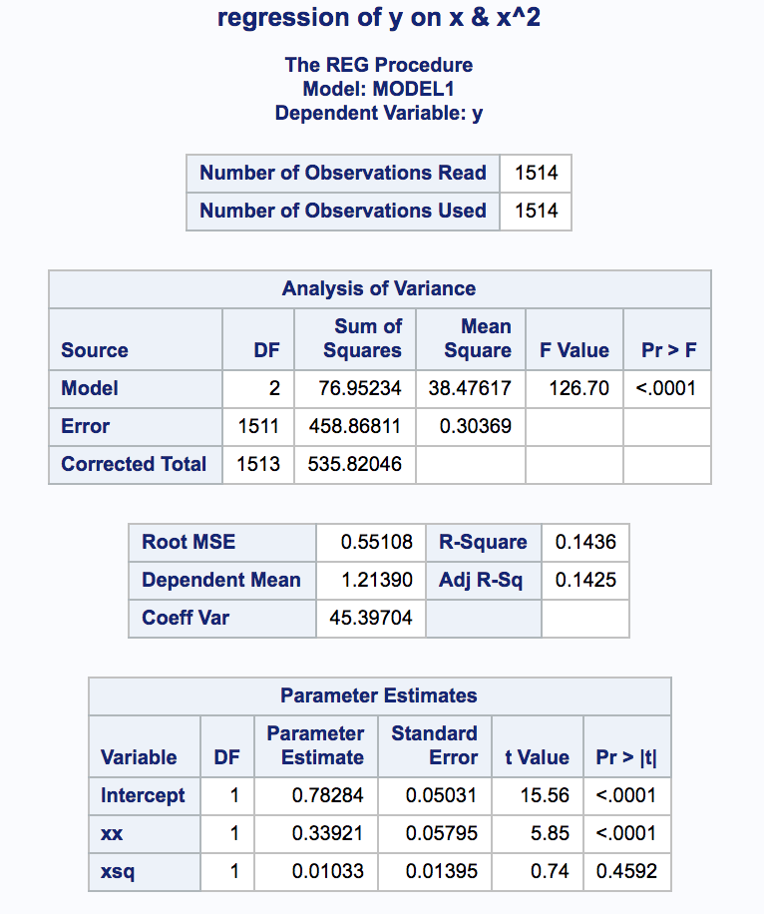

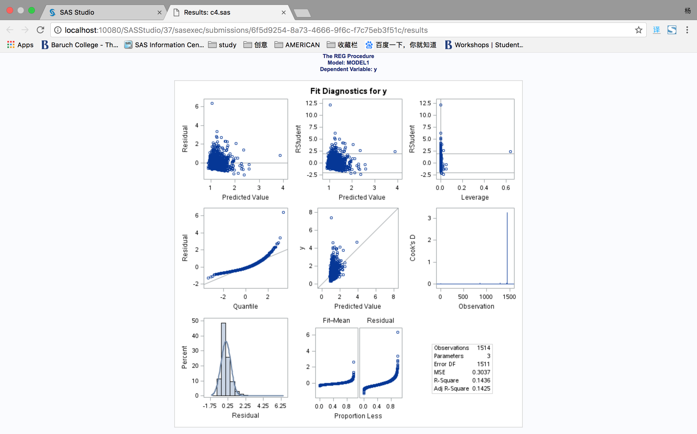

(c).

In the diagnostic plot, the leverage plot shows us the leverage of all points. The highest leverage point has the leverage values about 0.6.

(d).

The matrix used for computing the leverage values is the H matrix. The leverage measure of the ith point is given by its diagonal value in the H matrix, hii.

(e).

(i). The null hypothesis of F-test:

Ho: β1=β2=0;

Ha: either β1≠0 or β2≠0 or both.

It tests whether all the true population coefficients are 0, or at least some of them are significantly different from 0. Here, the null hypothesis is both β1 and β2 are 0, and alternative hypothesis is at least one of them are not 0.

The null hypothesis of t-test for intercept:

Ho: β0=0;

Ha: β0≠0.

The null hypothesis is the true population intercept β0 is 0, and alternative hypothesis is β0 not equal to 0.

The null hypothesis of t-test for coefficient β1:

Ho: β1=0;

Ha: β1≠0.

The null hypothesis is the true population partial slope for the first parameter, β1 is 0 and alternative hypothesis is β1 not equal to 0.

The null hypothesis of t-test for coefficient β2:

Ho: β2=0;

Ha: β2≠0.

The null hypothesis is the true population partial slope for the second parameter, β2 is 0 and alternative hypothesis is β2 not equal to 0.

(ii). For these hypothesis tests, we first assume the null hypothesis is true, and then we can get the F distribution and t distribution when the null hypothesis is true. By the mean and variances from the sample, we can use the same formula to compute the t-statistics value and F-statistics value.

By putting these two values into the distributions we get, we can compute the area inside the distribution that is either larger than the t and F-statistics values or less than negative t and F-statistics values. The sum of these two areas become the p-value. If the p-value is larger than 0.05, then the null hypothesis is not rejected. If the p-value is smaller thn 0.05, then the null hypothesis is rejected.

(iii). For the F-test, the null hypothesis is rejected because the p-value is less than 0.05. The conclusion of the test is that either one or the other or both of the true partial slope coefficients is not zero.

For the t-tests, all the null hypothesis is rejected because the p-values are less than 0.05. The conclusion of t-test is that true intercept β0, partial slopeβ1 and β2 are not equal to zero.

(f). A “fun” polynomial regression plot is shown, such as this one.

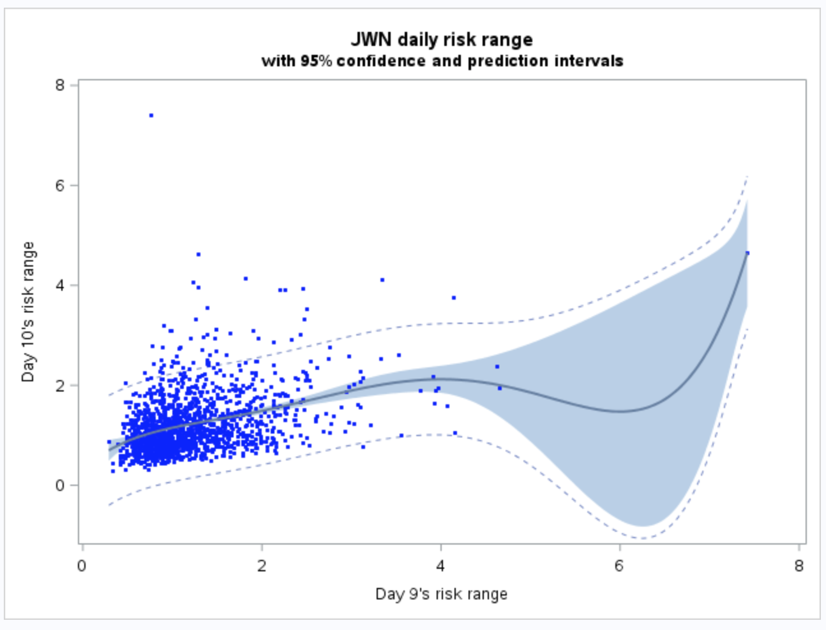

(g).

The higher-order polynomial fit doesn’t not produce a better result. In my data set, there are a lot of sample points lie on the left of the plot. The usage of higher order polynomial model doesn’t decrease the heteroscedasticity. The difference between second order fit and third order fit is only whether the leverage point on the right side is included or not. For the third order and fifth order fit, the lines they produced are not different so much. In both simple regression and high-order polynomial regression, the points having ‘Day 10's risk range’ values from 2 to 6 keep being excluded from the confidence interval.

2. Multiple Regression with a Dummy Variable and an Interaction Term

(a). The SAS code is used to produce a dummy variable.

**data** c4_2; set range;

y=day_10;

x1=day_9;

x2=day_8;

if x2 > x1 and x1 > y then dumtrend= **1**;

else dumtrend= **0**;

keep y x1 x2 dumtrend;

**run**;

Here, the risk range on a daily basis of the stock, JWN is used. X1 is the risk range of day 9, x2 is the risk range of day 8 and y is the risk range of day 10. Remember, our idea is trying to estimate day 10’s daily risk range with the past 9 days’ data.

Dummy variable is defined 1 if the daily risk range x1 is larger than the daily risk range x2 and also the daily risk range x2 is larger than the daily risk range for the day we analyzing.

The idea is that if the trend of a decreasing daily risk range for 2 continuous days, we give them a mark.

Interaction variable is computed by dummy variable multiplying x2. So if the trend of a decreasing daily risk range is true, we take x2 into account; otherwise, we only need x1.

(b). The following SAS code defines a interaction variable.

**data** c4_2;

set range;

y=day_10;

x1=day_9;

x2=day_8;

inter = x2 * x1;

keep y x1 x2 inter;

**run**;

Here, the interaction variable is defined simply as x1 multiplying x2.

(c). original dummy

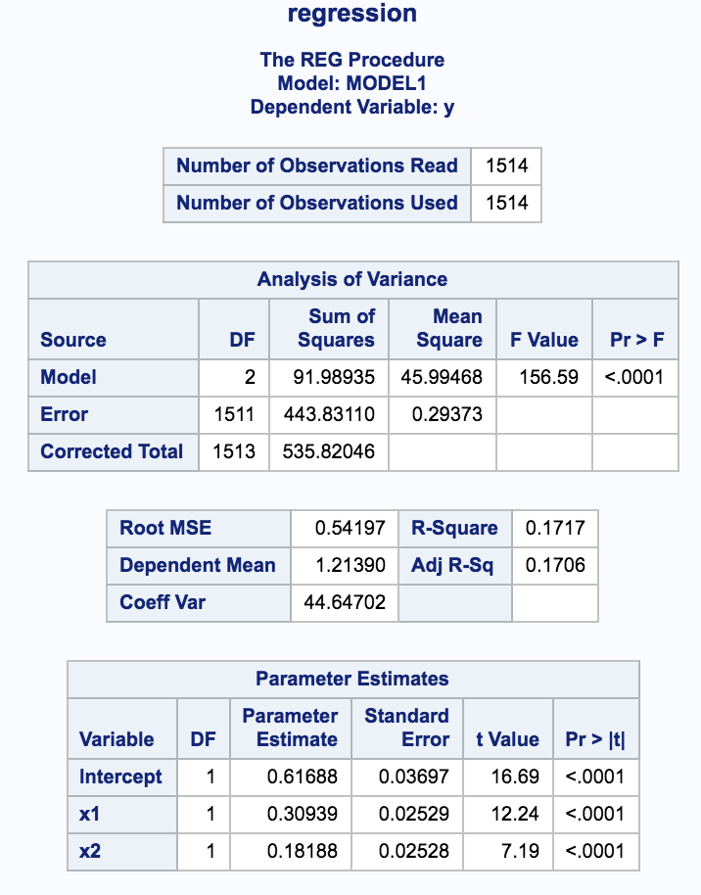 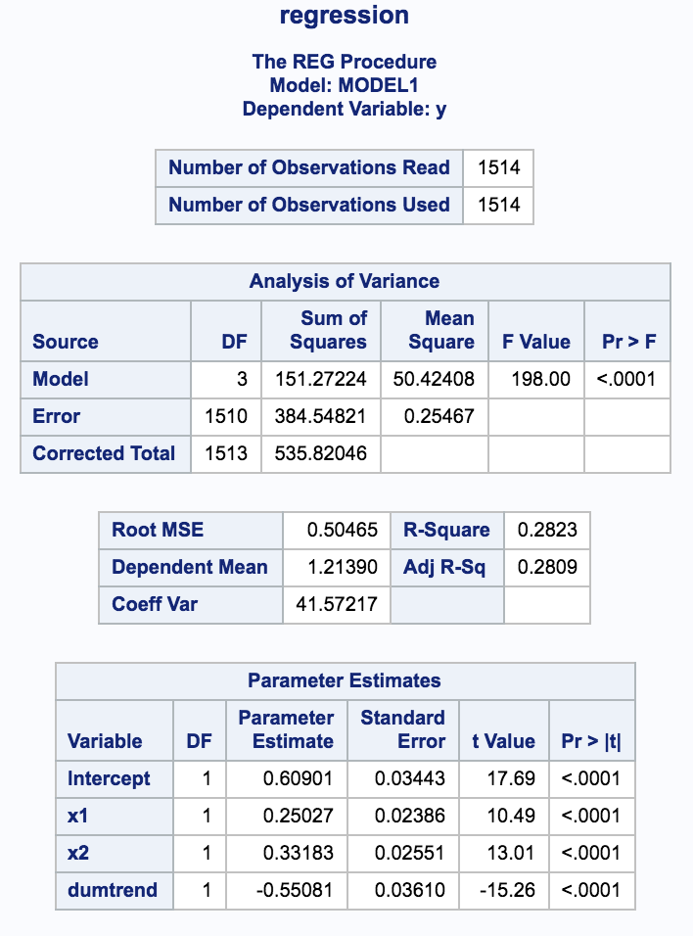

interaction

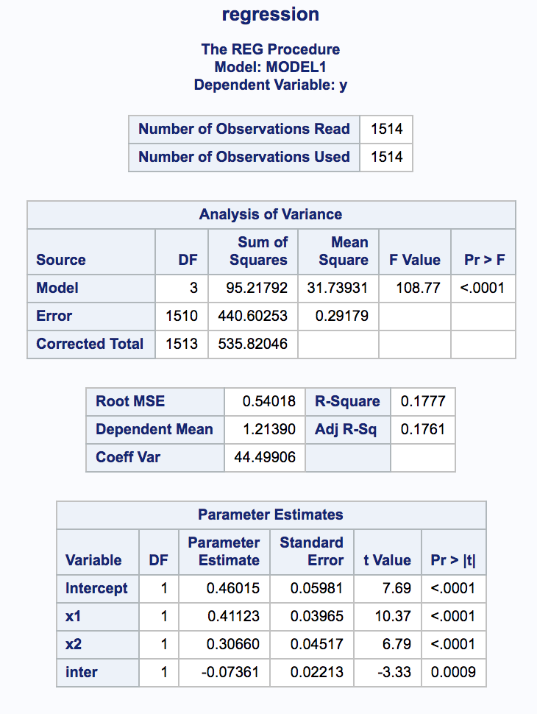

(c).

The dummy variable supplies a separate y-intercept for the daily risk range with a trend and without a trend, but they will share the same slope for the *x1* and *x2* variable. Here, If daily risk range has a trend that the risk range is decreasing by time, then the equation will be,

= 0.60901 + 0.25027 x1+ 0.33183 x2.

But, if there is a decreasing trend on daily risk range,

= (0.60901 - 0.55081) + 0.25027 x1+ 0.33183 x2.

The intercept of the equation is reduced by inclusion of the dummy variable. In addition, the difference in the intercepts is found to be statistically significant, which means the coefficient of the dummy variable is not 0. This might indicate that if risk range in the past dates is keeping decreasing, the risk range for the current day might be smaller.

The dummy variable is statistically significant, which is quite interesting. Also, by introduction of the dummy variable, the adjusted R-square is increasing a lot, from 0.1706 to 0.2809, which means the introduction of dummy variable improve the fit of the model.

(d).

The interaction variable is simply as x1 multiplying x2. It gives us a view of collinearity inside our variables.

In the plot of ‘inter’ vs. x1, we see there is a collinearity than between x1 and x2, and also there is a remarkable leverage. In plot of ‘inter’ vs. x2, we also have a remarkable outlier point.

We need to check if the interaction terms should be included is to examine the adjusted R-square for this model against the one without interaction variable. Here, we have adj R-sq of 0.1761, whereas it was 0.1706 without interaction variable.

Thus, we have only increase a little bit in terms of the adjusted R-square metric, so including the interaction term has shown no benefit. Interaction variable does not introduce another regressor with a linear relationship with y.

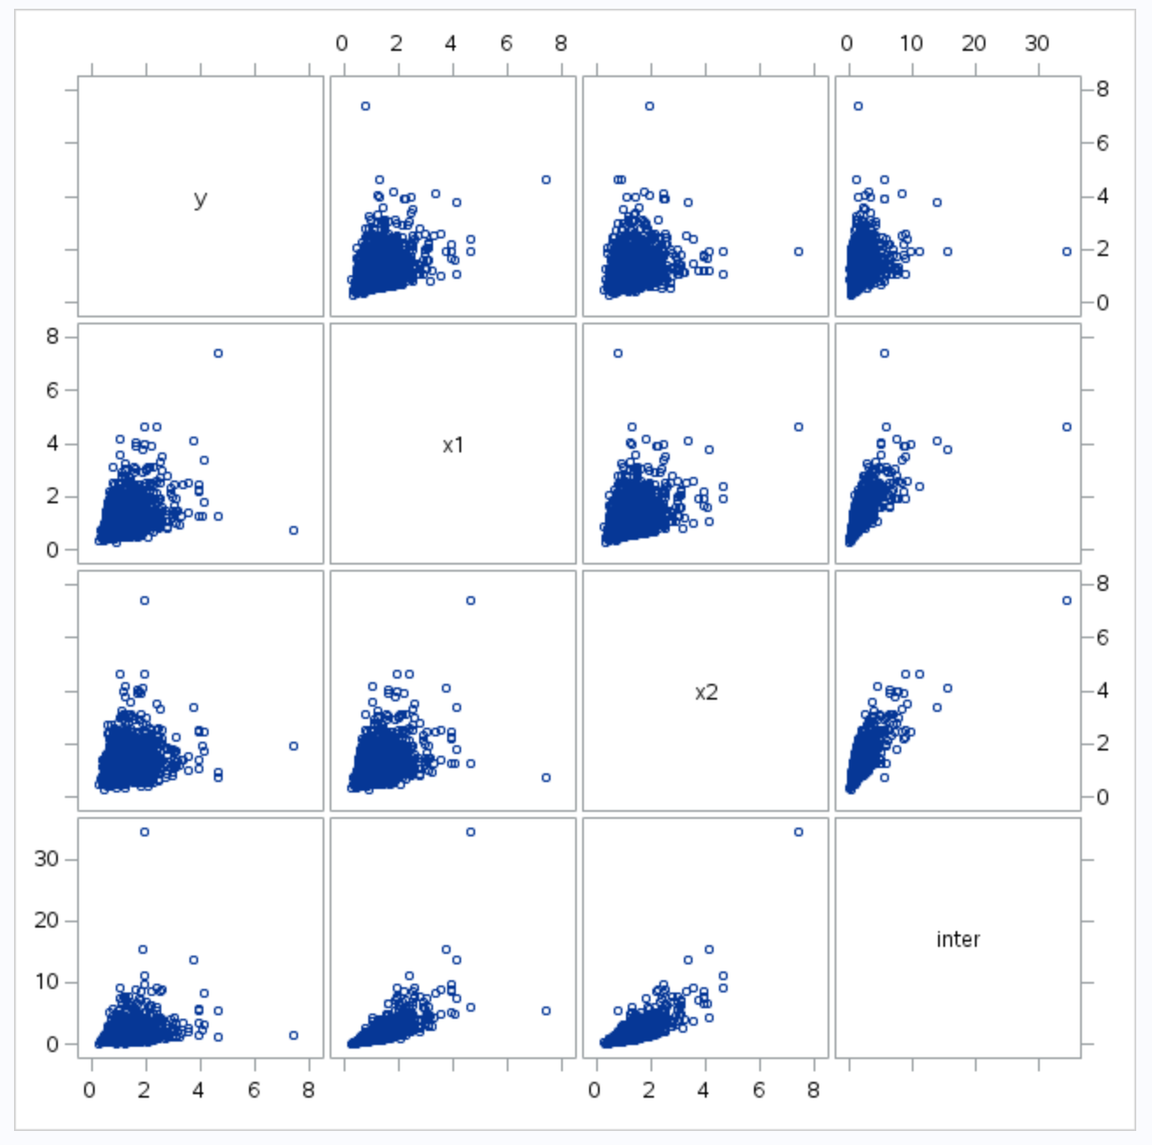

**Chapter 5. Model Selection**

1. Best Subsets Model Selection

(a). The full data set is used to show the matrix scatterplot for the original data.

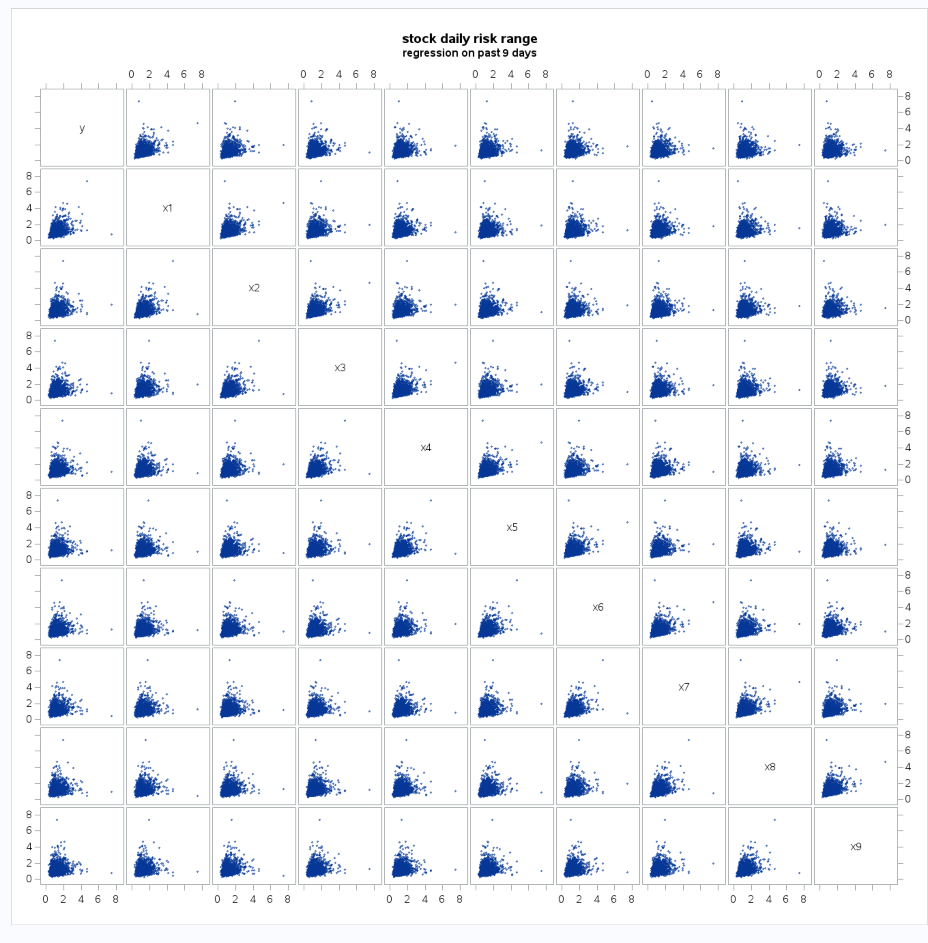

(b).

Most of the data points are centered on the left corner of the scatterplot. Also, we have 2 outliers need to solve. The shape of points are not fitted into an oval. Here, we will take a Natural log transformation of all the variables.

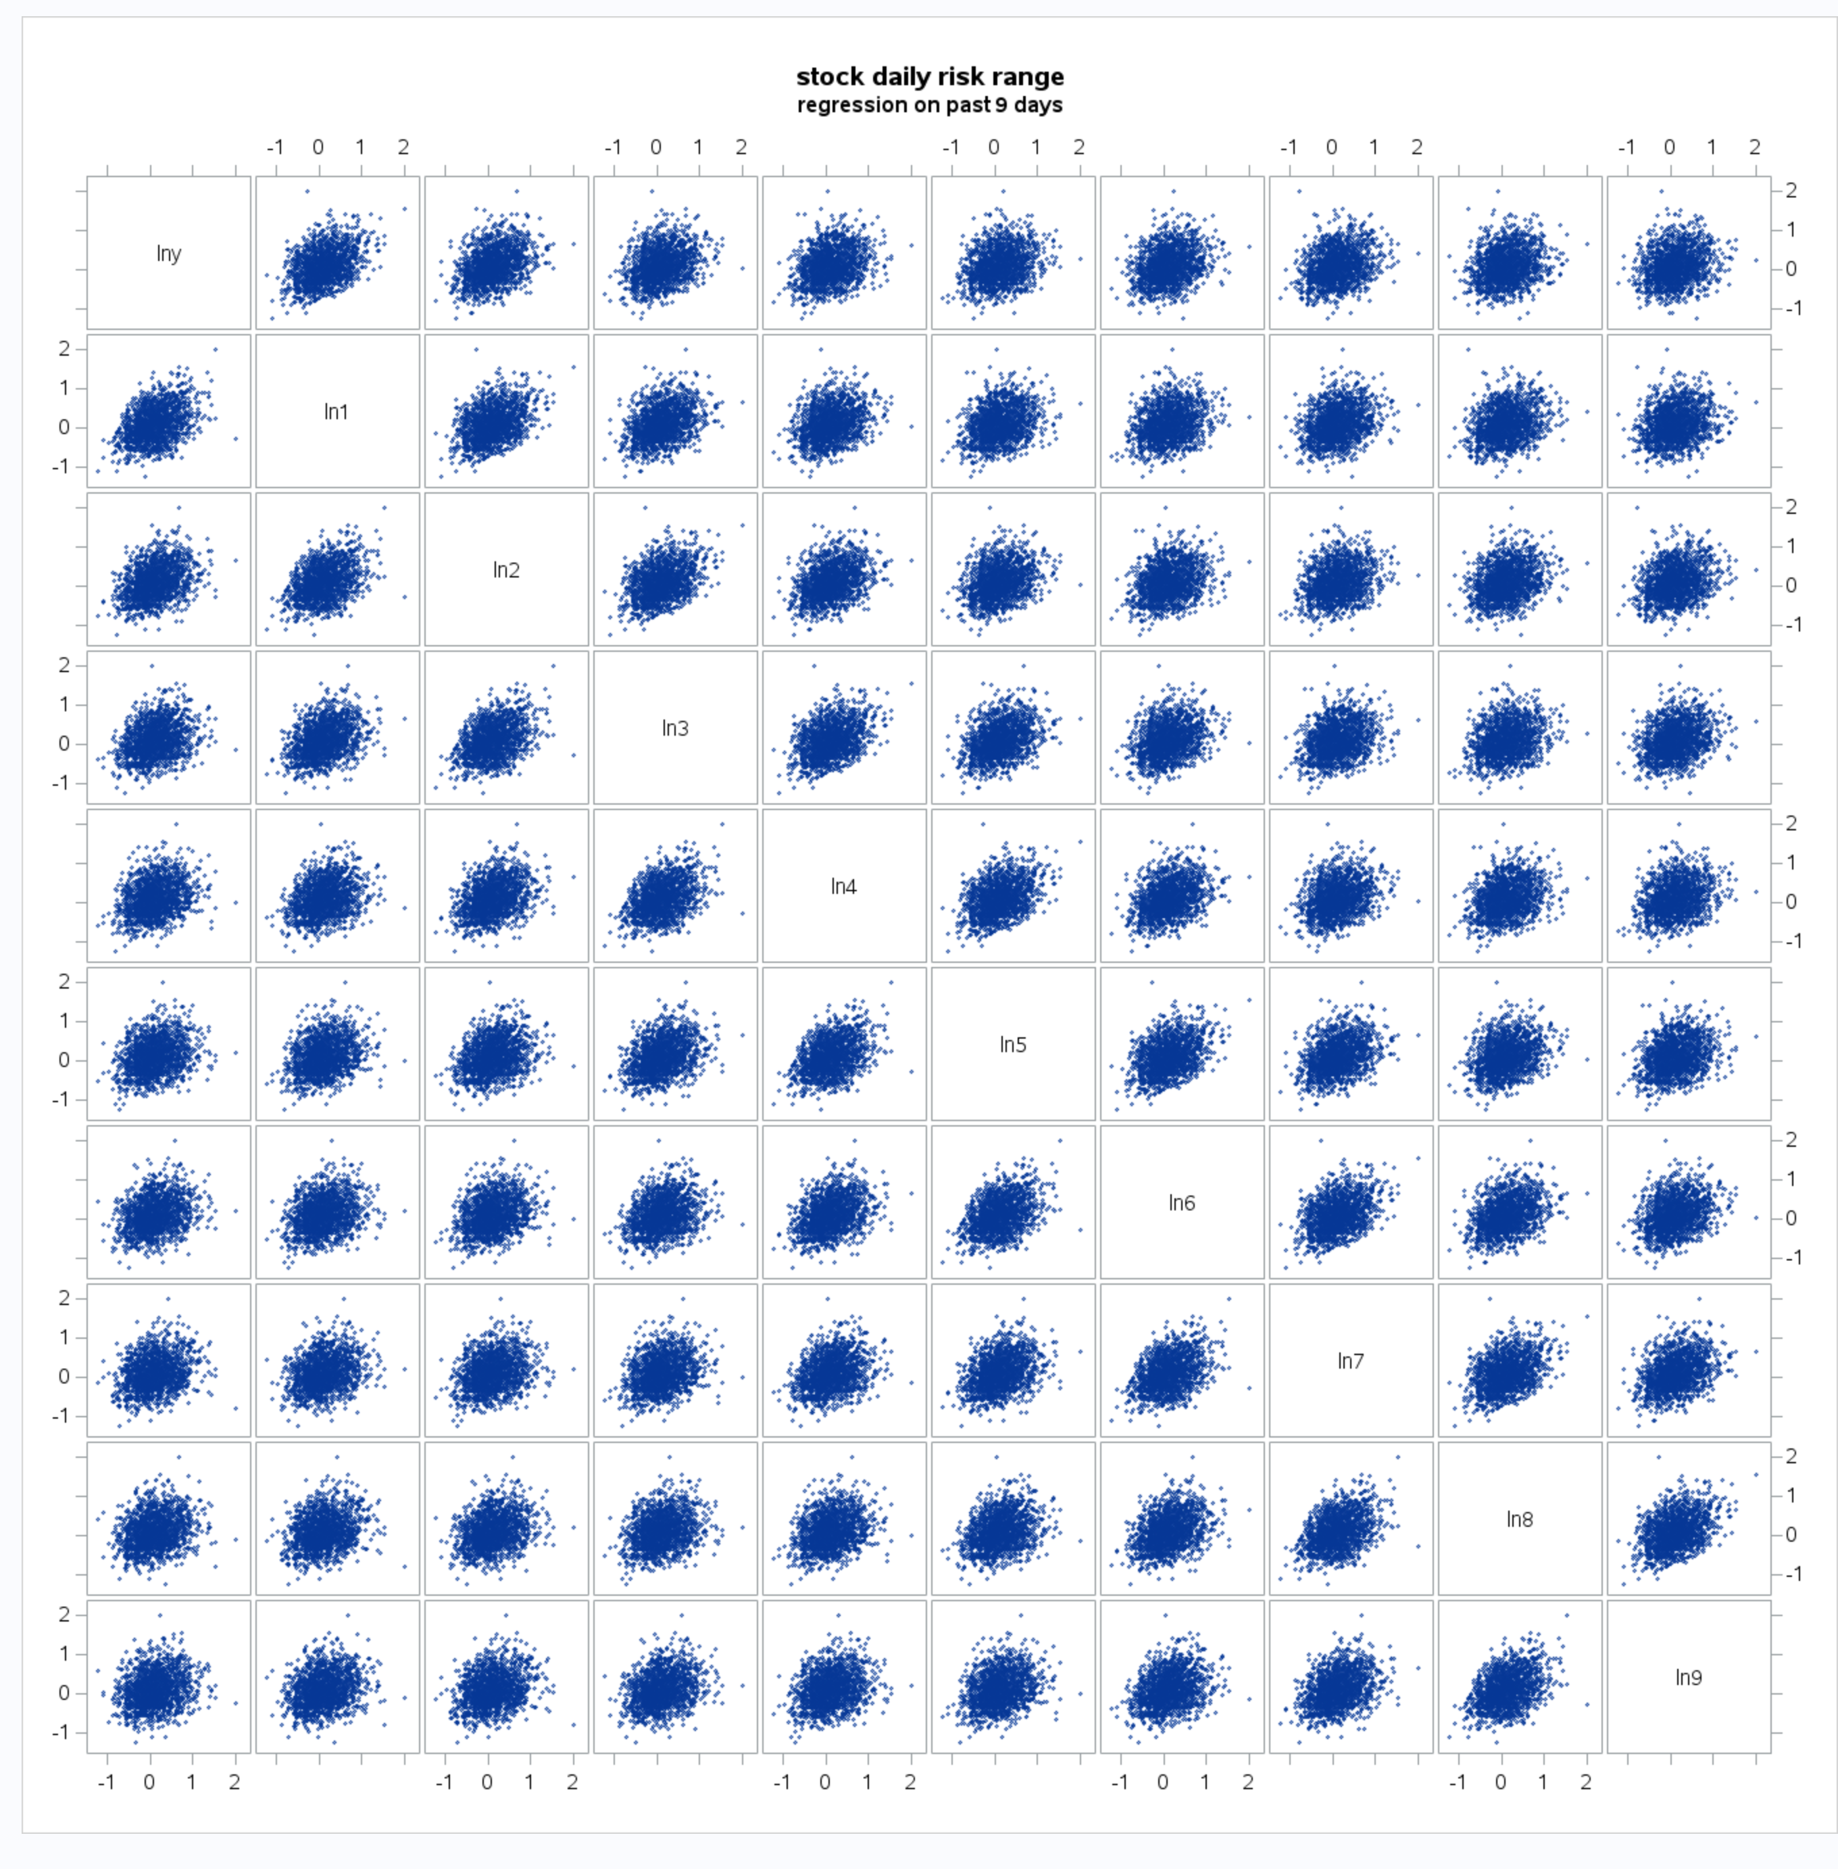

(c). SAS runs the best subsetmodel and provides the criteria plot.

Criteria Plot:

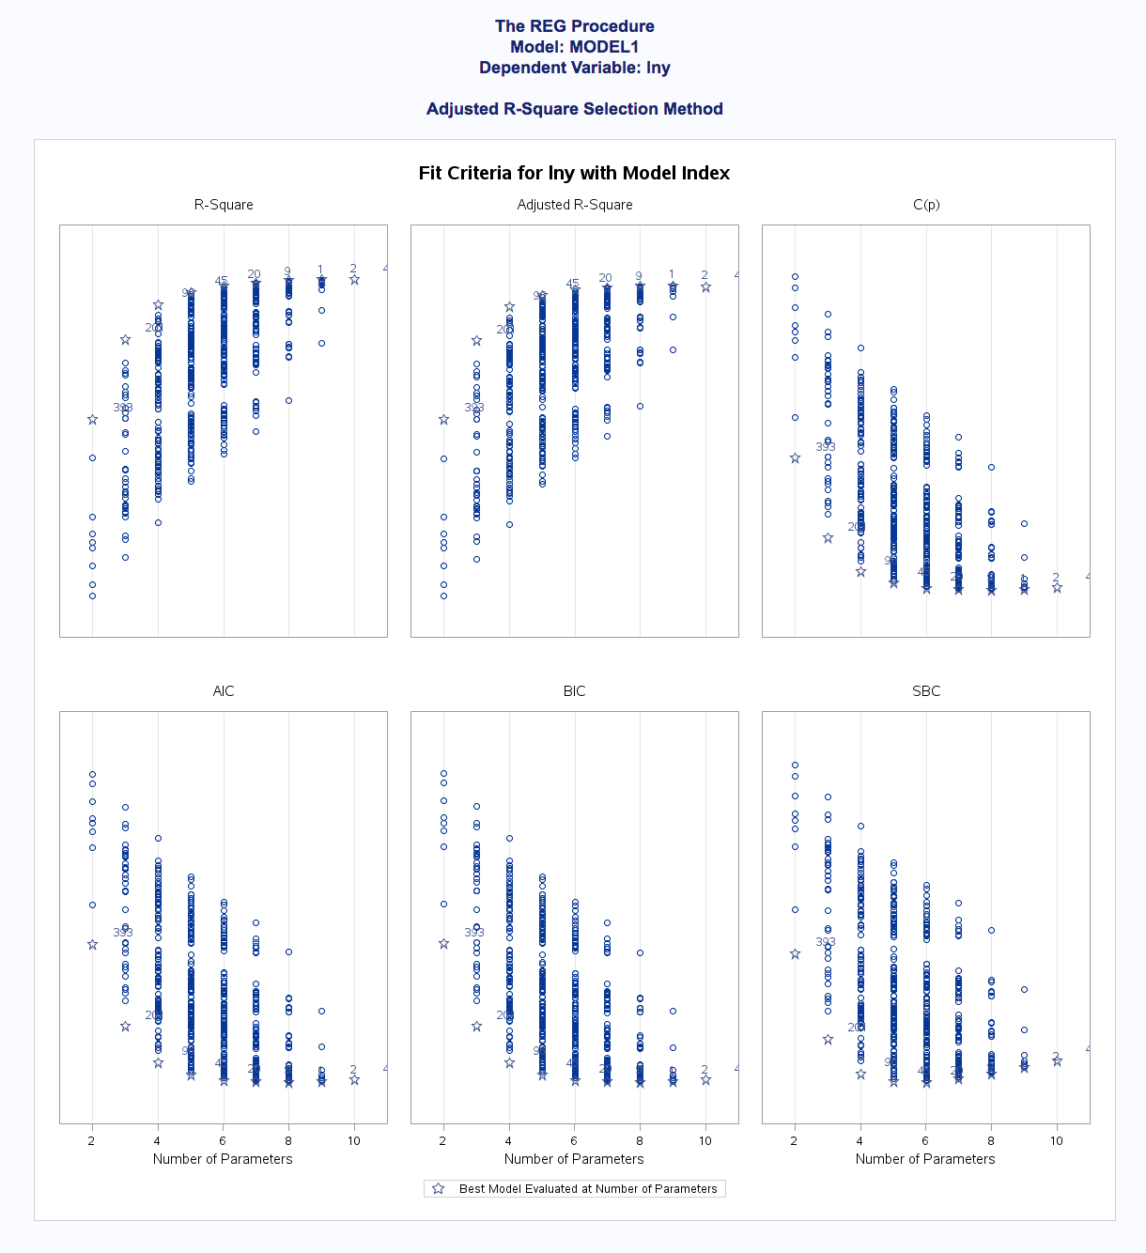

Summary table: (Due to too many results, only partial table will be shown)

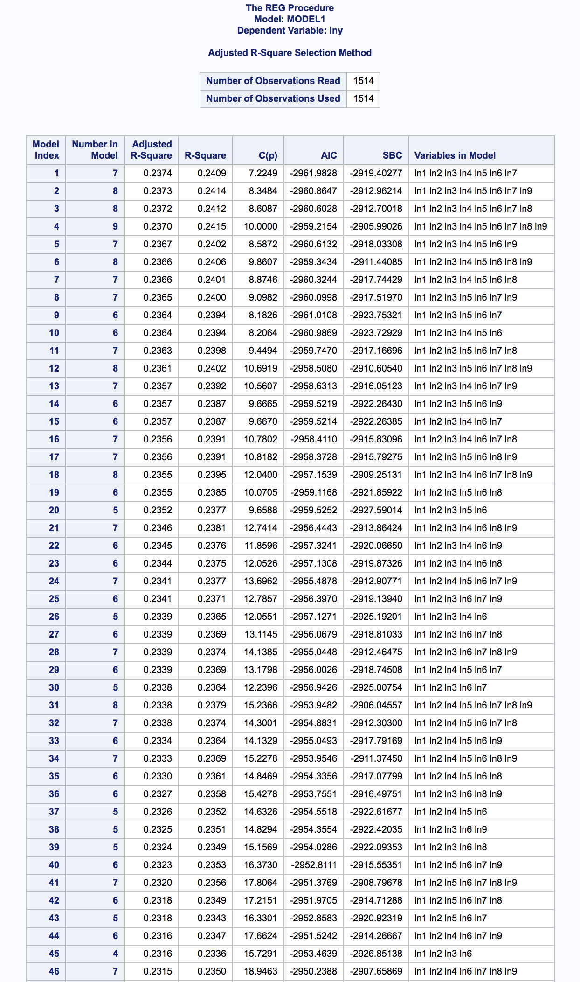

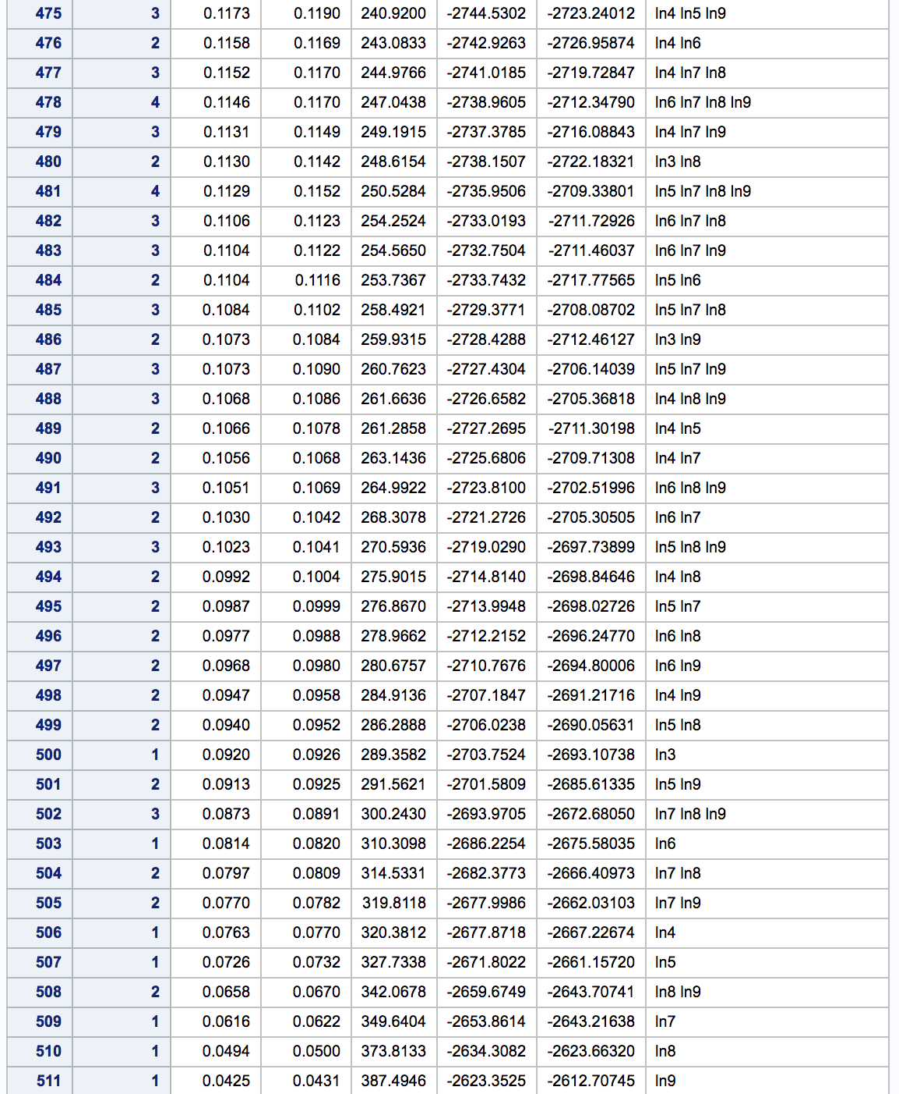

(d).

The best model should be the model with the smallest values on these information criteria. For Mellow CP, the model with 5 and 6, including the intercept, gives the smallest value. For BIC and SBC criteria, the 5 and 6 parameters’ models are very close in their values. In the SBC, we can see the model with 6 parameters giving the smallest value. The 5-parameter model with the smallest AIC value is model 40. In the summary table, model 40 includes variables ln1, ln2, ln5, ln6, ln7, ln9(square root of original variables x1, x2, x5, x6, x7, x9).

(e).

Here, the labeled version is also used to get the diagnostic plot because too much labels on such a small graph might be a chaos.

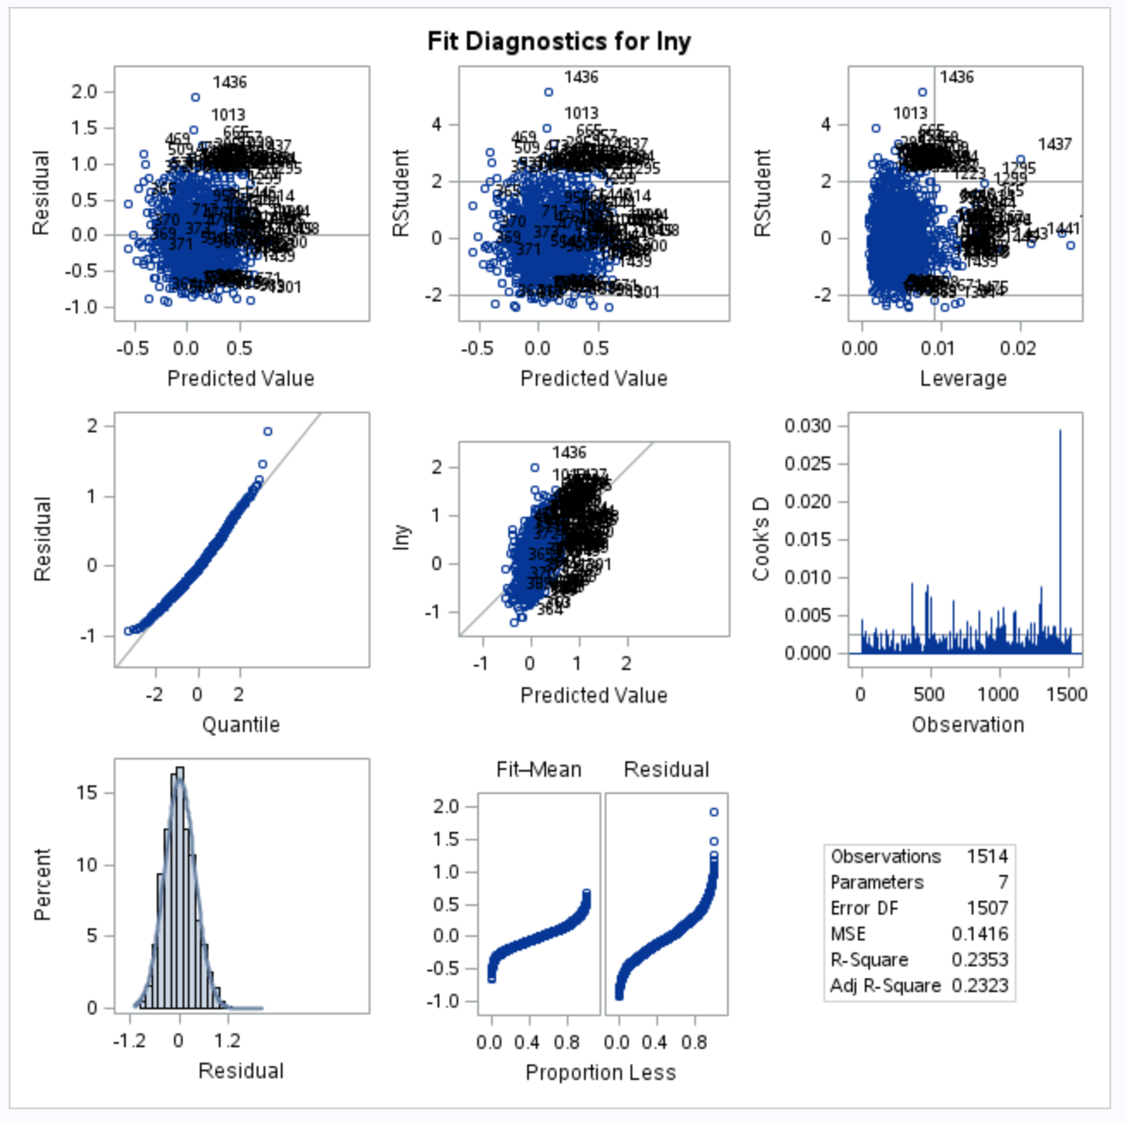

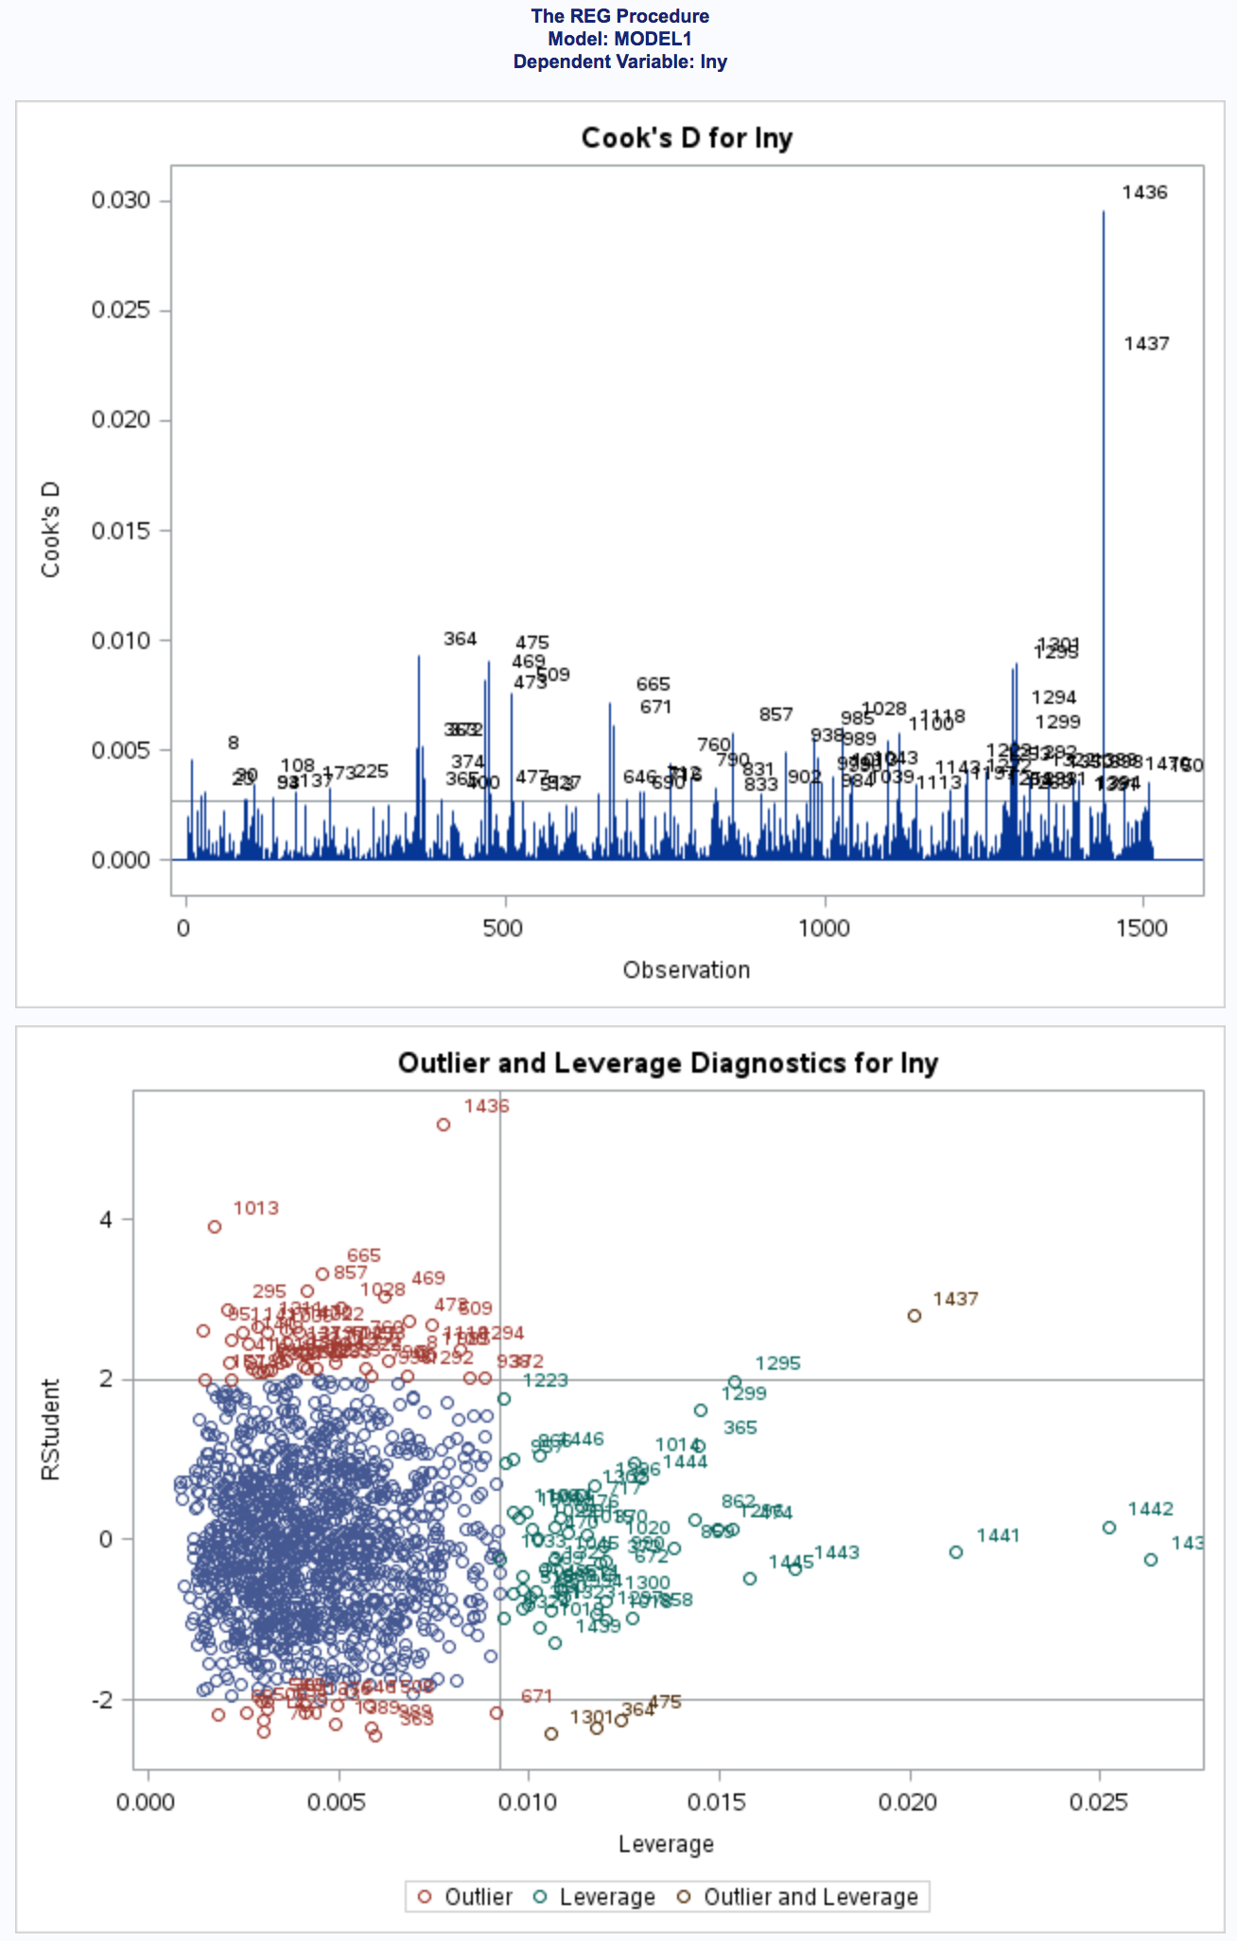

2. Forward Stepwise Model Selection

(a).&(b).

SAS bring in a variable based on its partial R-square value. Here, the variables we use is sqrt, the square root transformation of the original daily stock risk range and lag data.

According to the summary, the program first selected the ln1 variable for inclusion. It then added the ln2 variable and did not remove ln1. Next, the ln6 variable was added. After that, the program interestingly add ln3 and ln5, which seems inclusion of ln5 has more impacts on the partial coefficient of other variables.

The stepwise process provides a very similar model as recommended by AIC and BIC, as the 7-parameters model in the AIC, SBC and BIC also has a second small value.

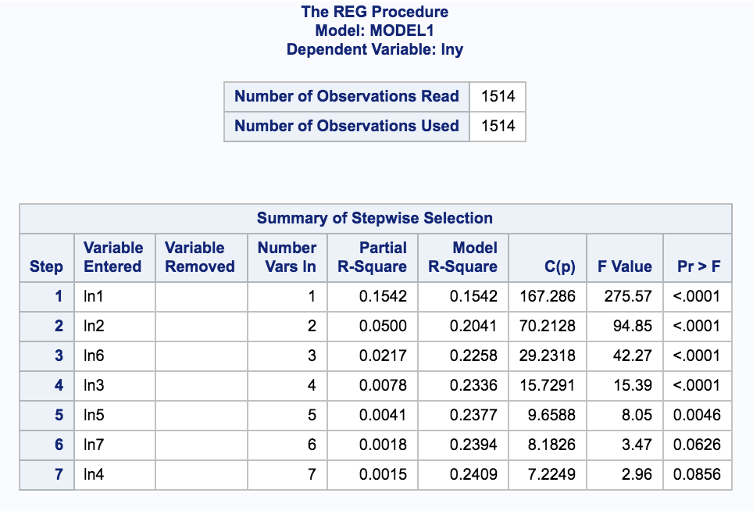

3. Variance Inflation

(a). The VIF of regressor k is

VIFk = (1 - R2k)-1,

where, R2k is the R-square statistic resulting from the regression of kth variable on the other x-variables in the model. It quantifies how much the variance is inflated. The variance here indicates the standard errors of the slopes which are inflated when multicollinearity exists. If the correlation between that variable and the remaining x-variables is low, then the VIF will be close to 1.0. But, if the correlation is high, then the VIF can be enormous. So if there are variables with high VIFs, we might have to remove some of them from our model.

(b). The selected model is run with the VIF output. VIF values are small and no outrageous values are found.

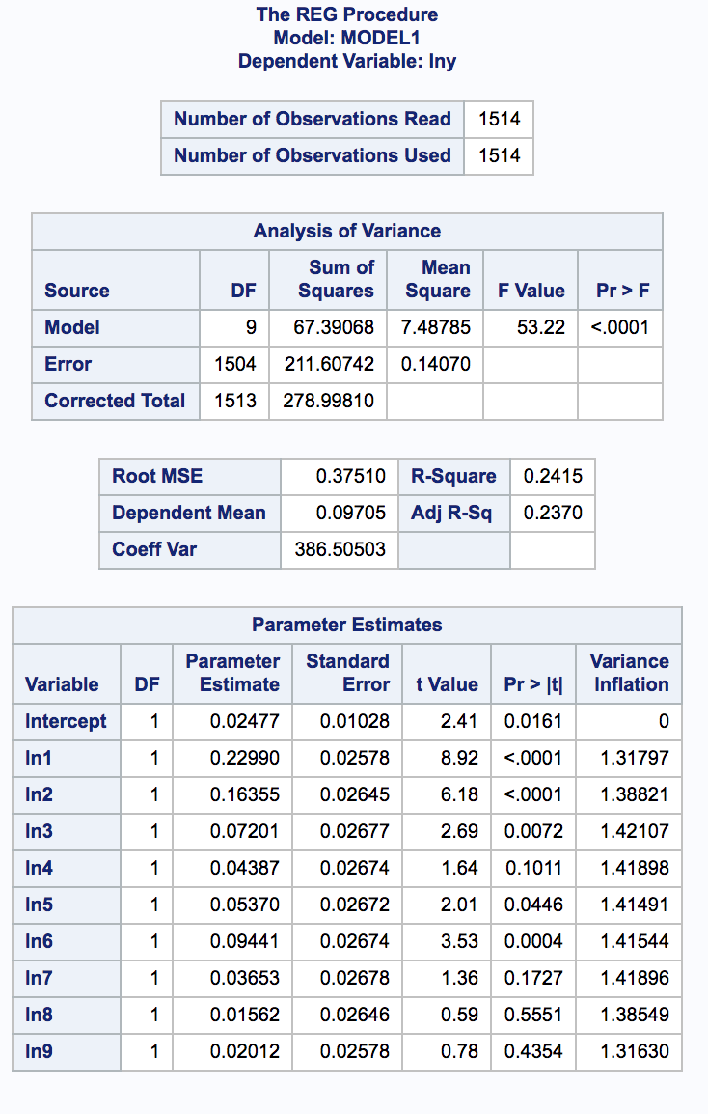

4. The Press Residuals

(a). The deleted residuals from proc iml match the press residuals from SAS. A subset from the original data is used.

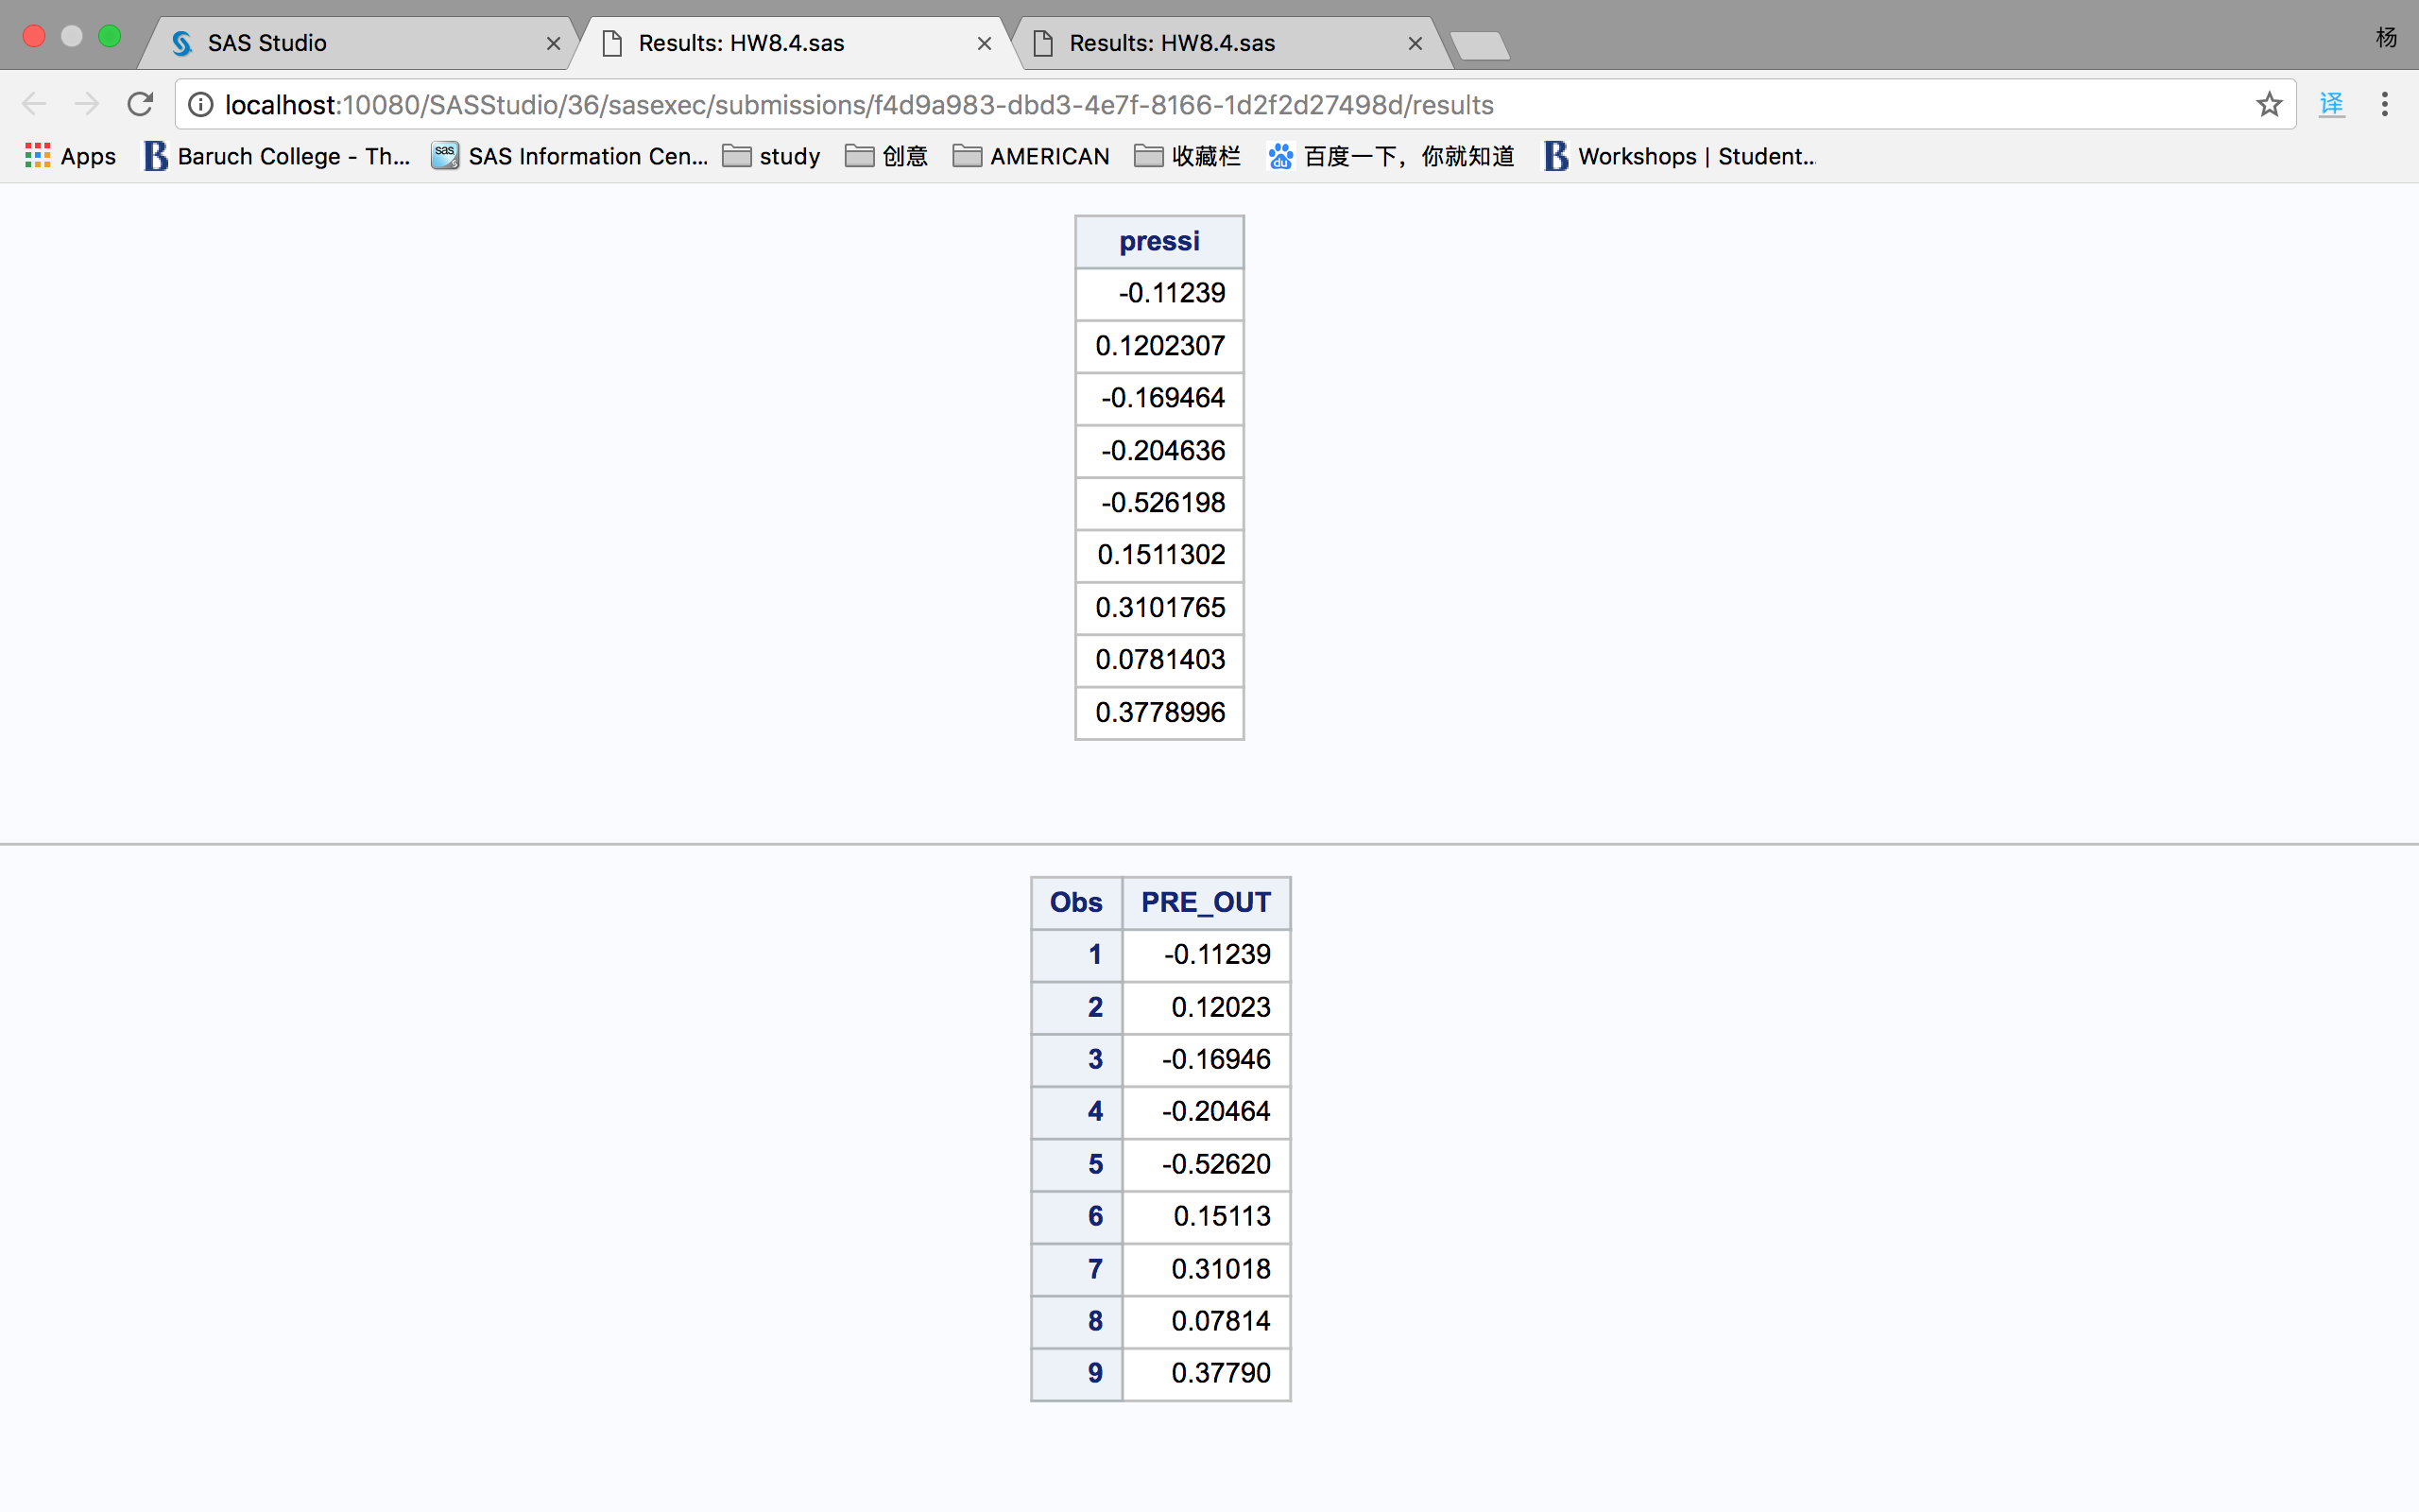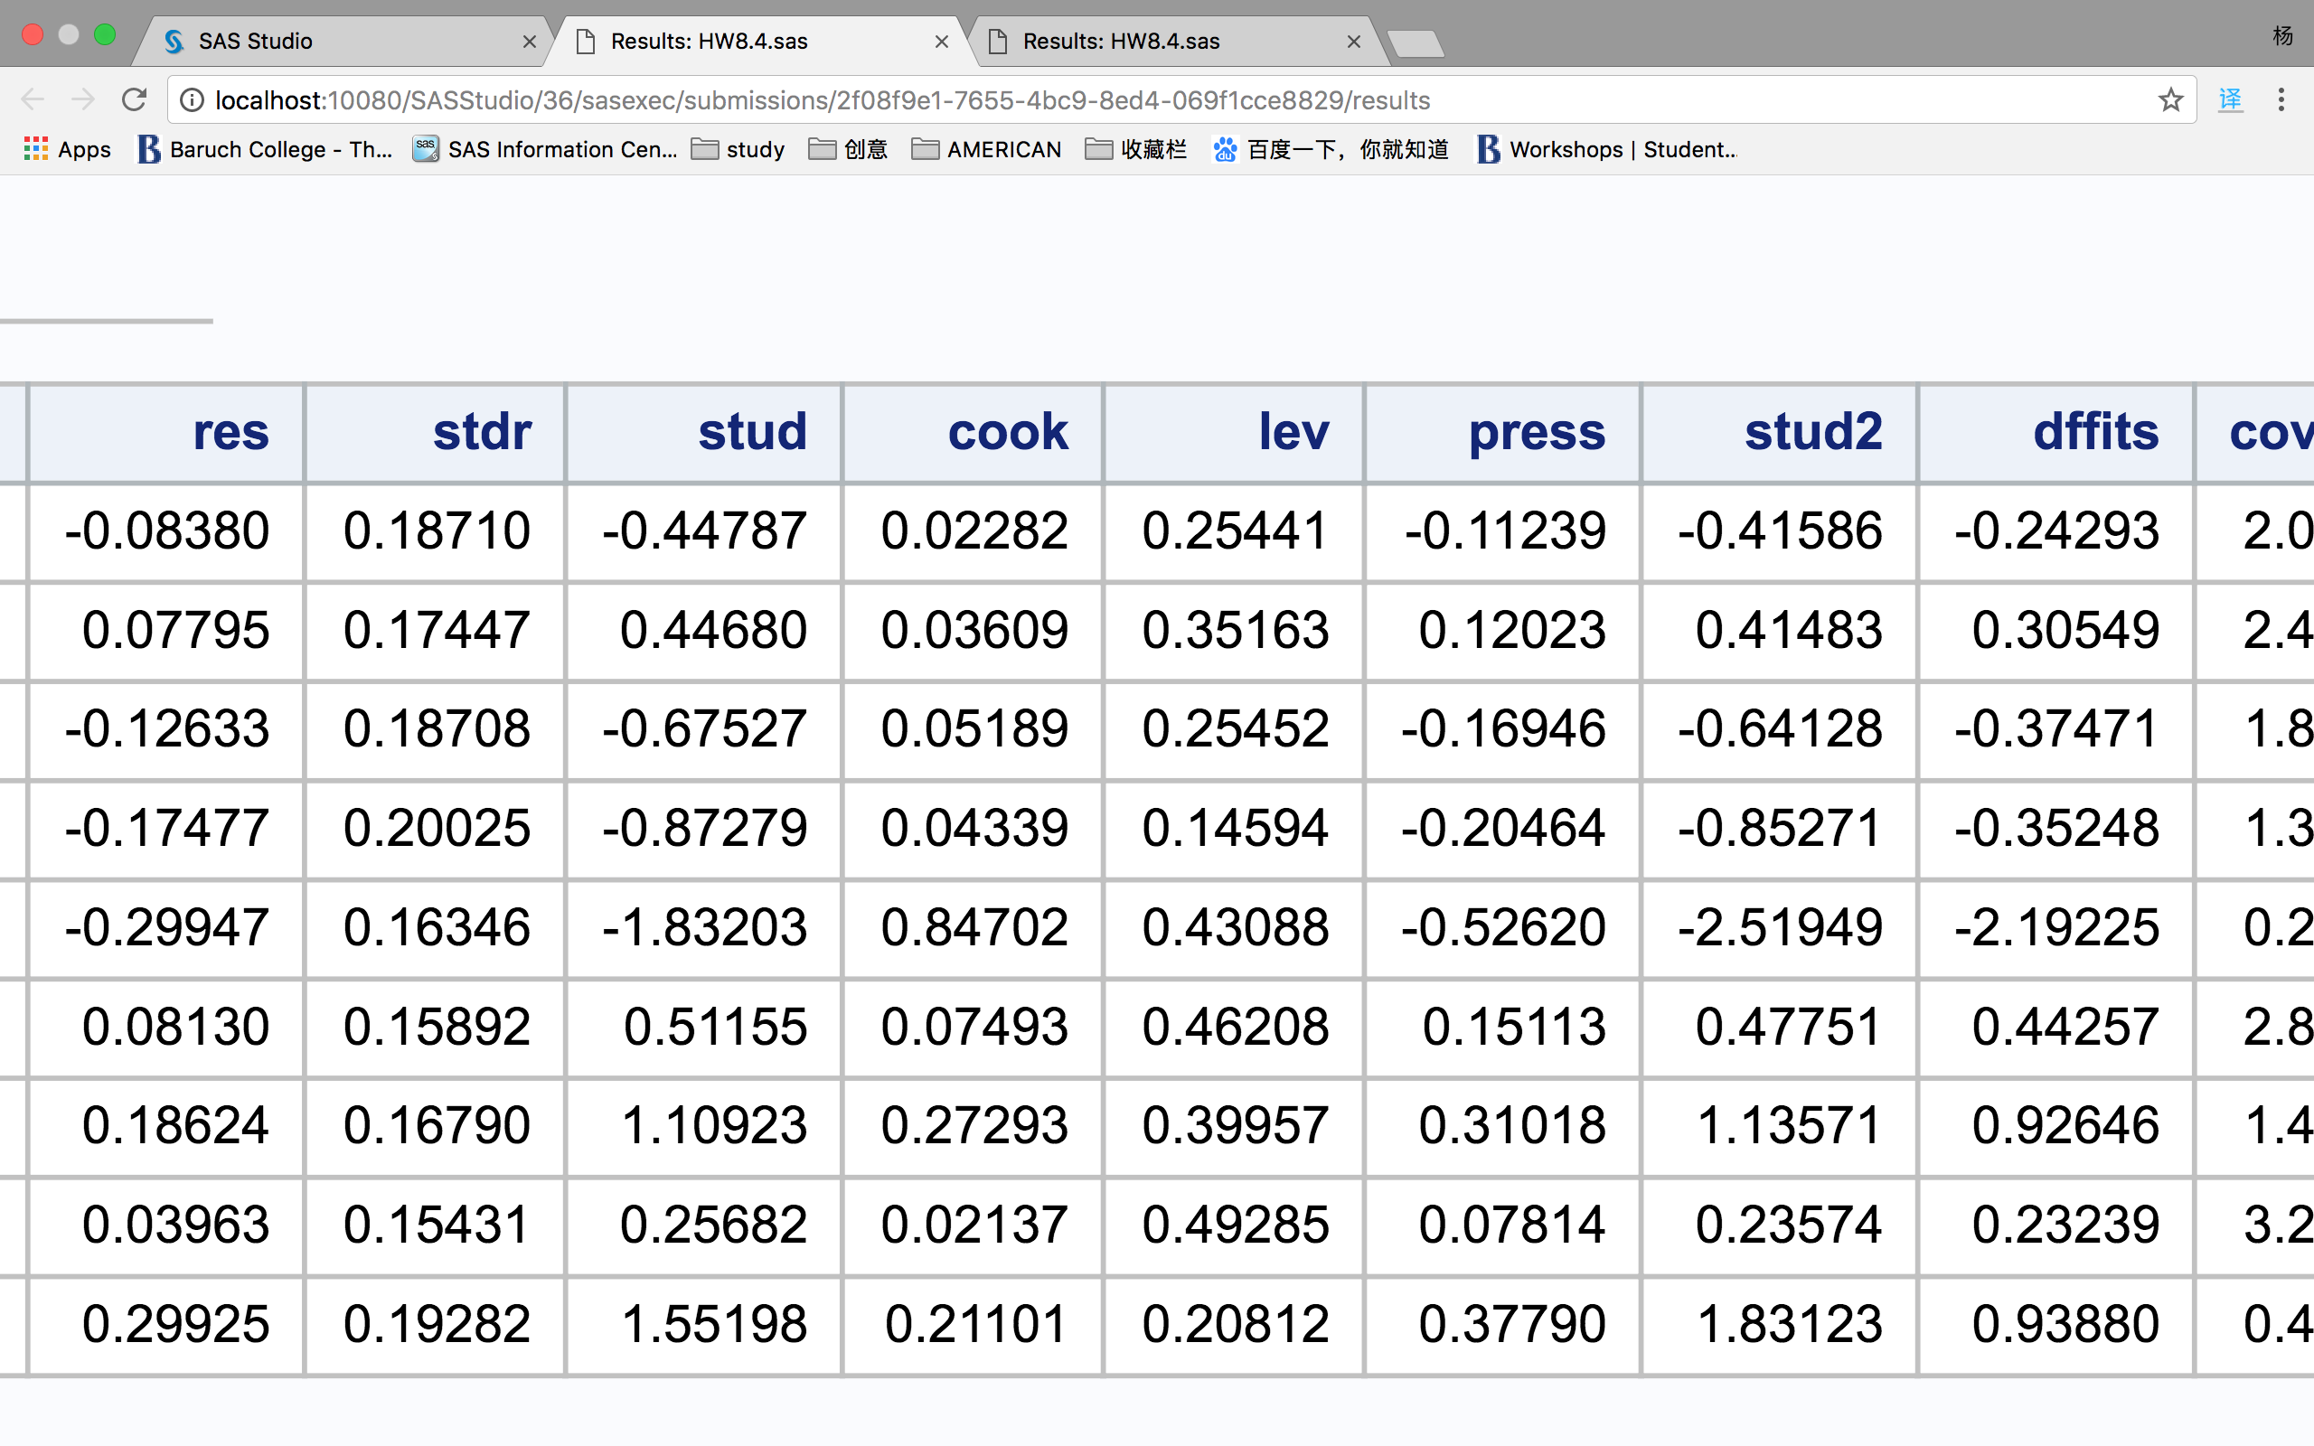

(b).

Step 1~3 remove the ith row from the data set. For i=1, it removes the first row in both X variables and the Y variable.

Step 4 compute the partial slopes and intercept for the data set without ith row.

Step 6 compute the “out of sample” yhat value by using the deleted x row and the partial slopes we get in the Step 4.

Step 7 computes the press residuals by using difference between the observed ith y row which is also removed in Step 1 and the yhat in Step 6.

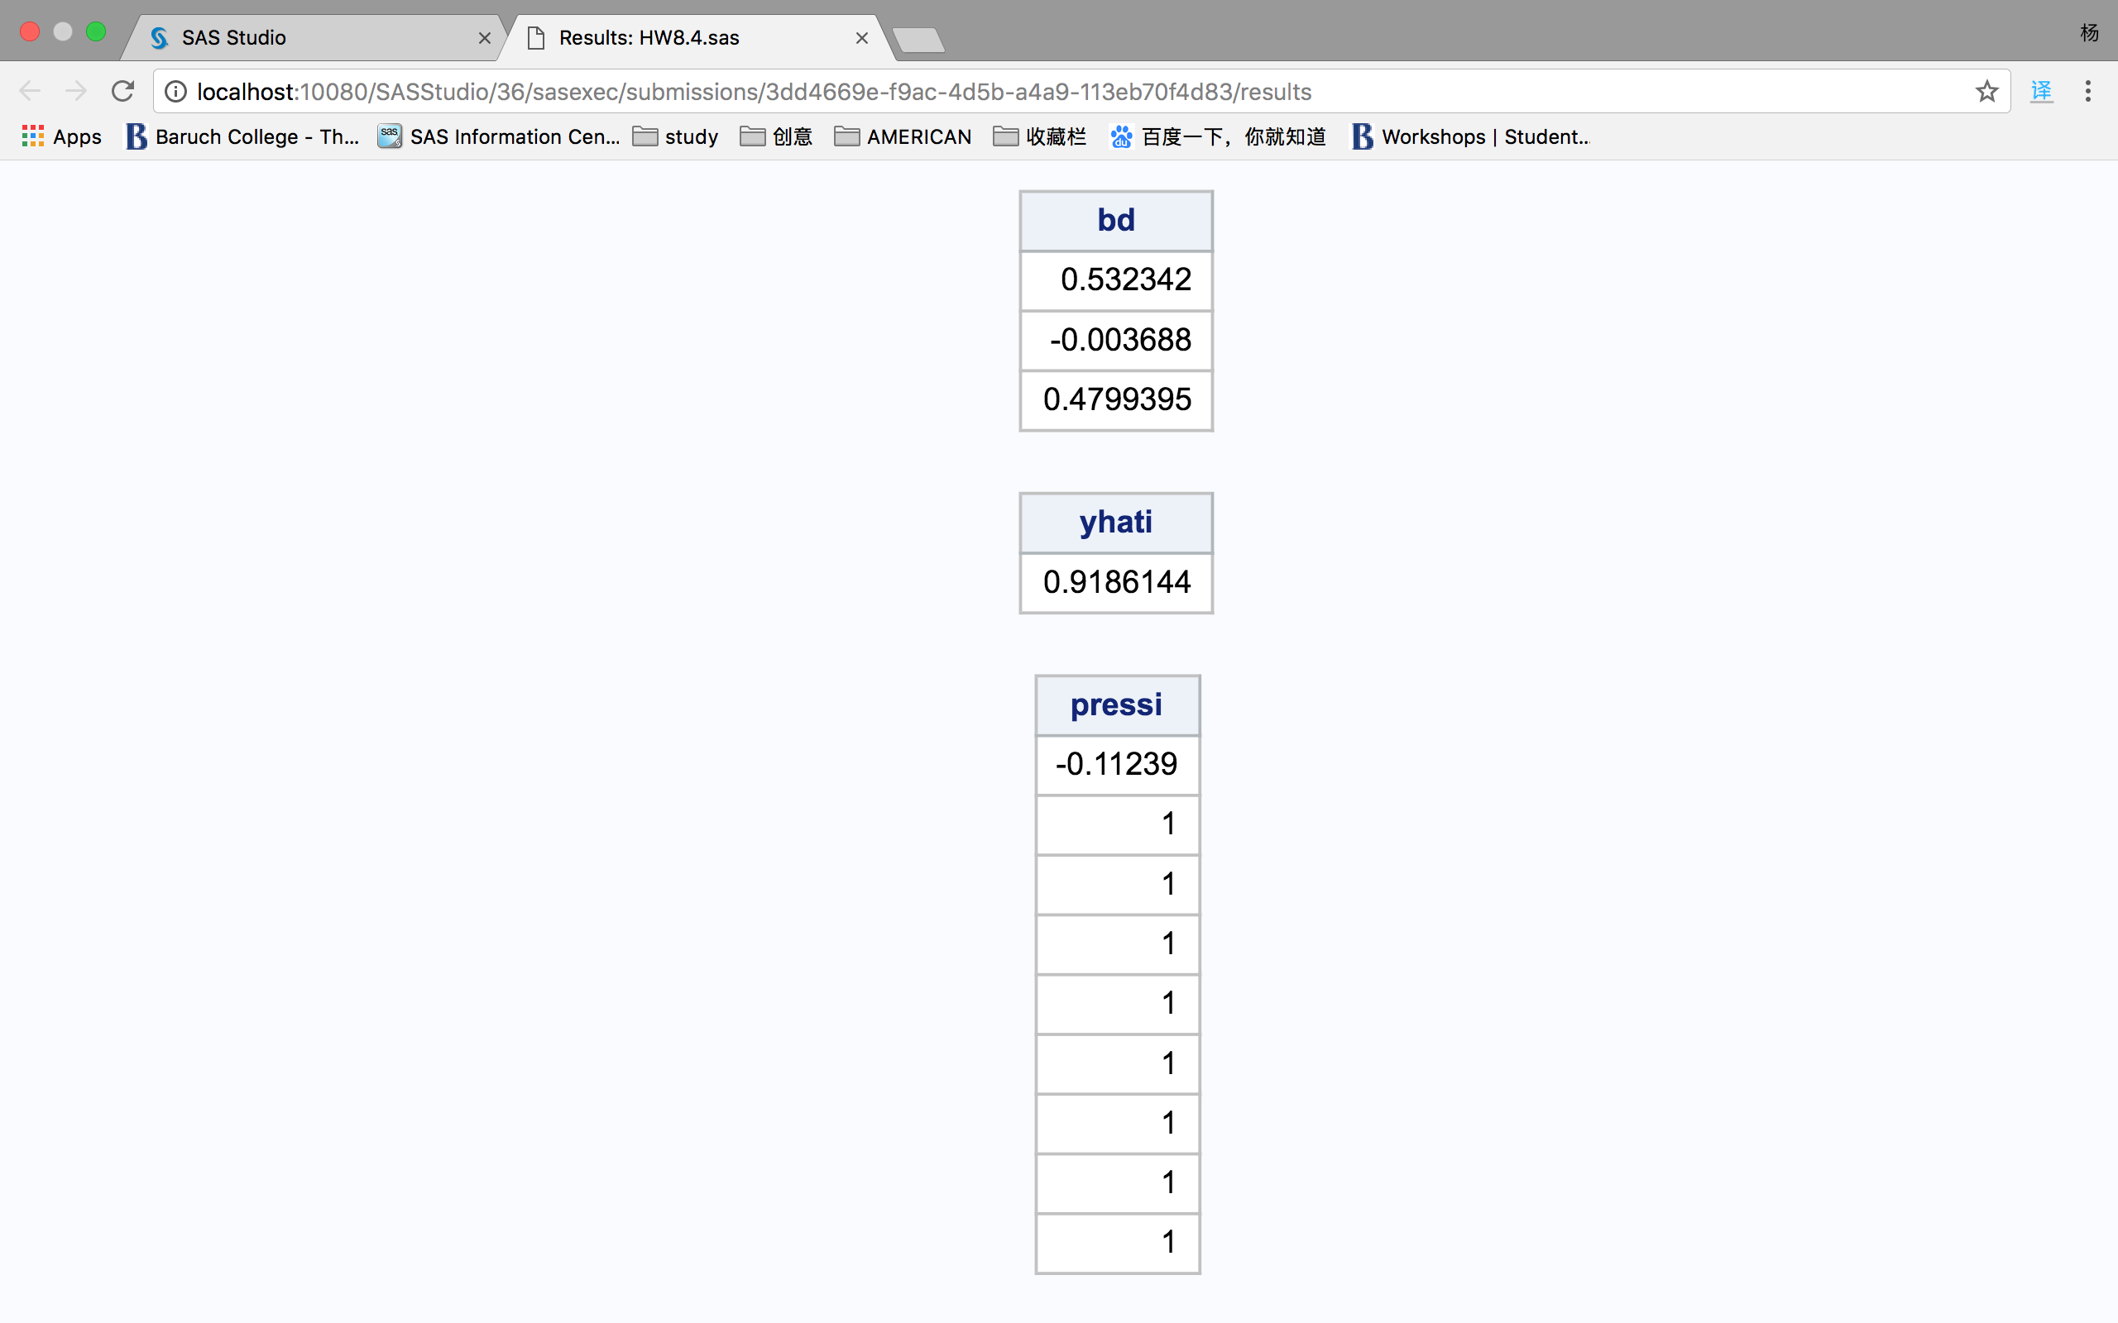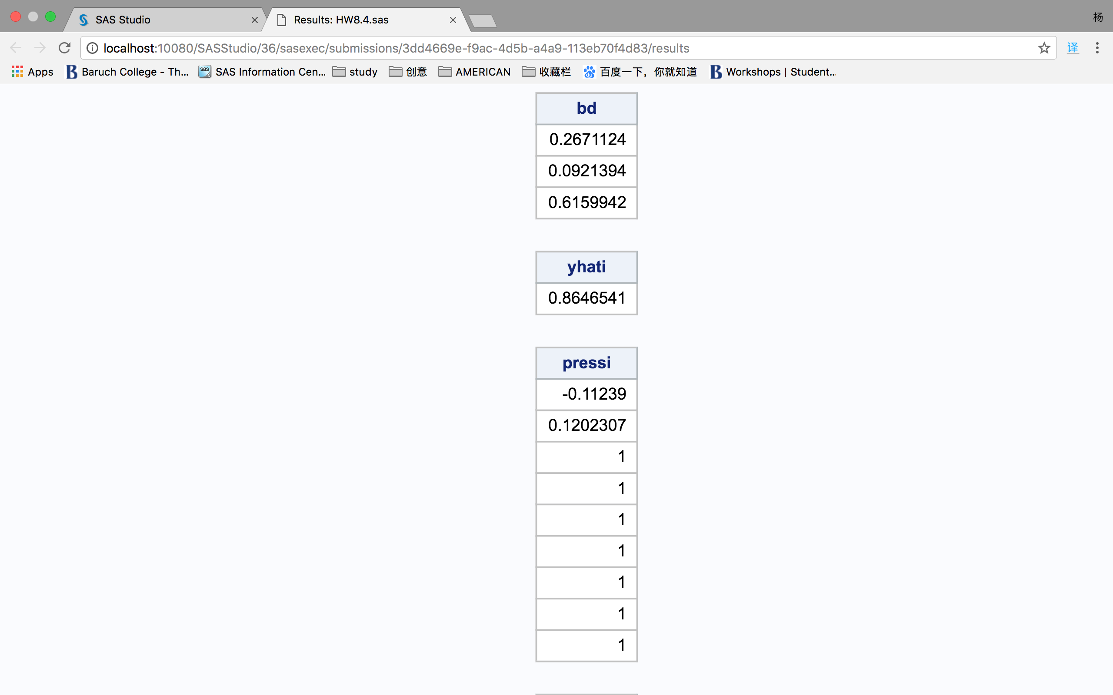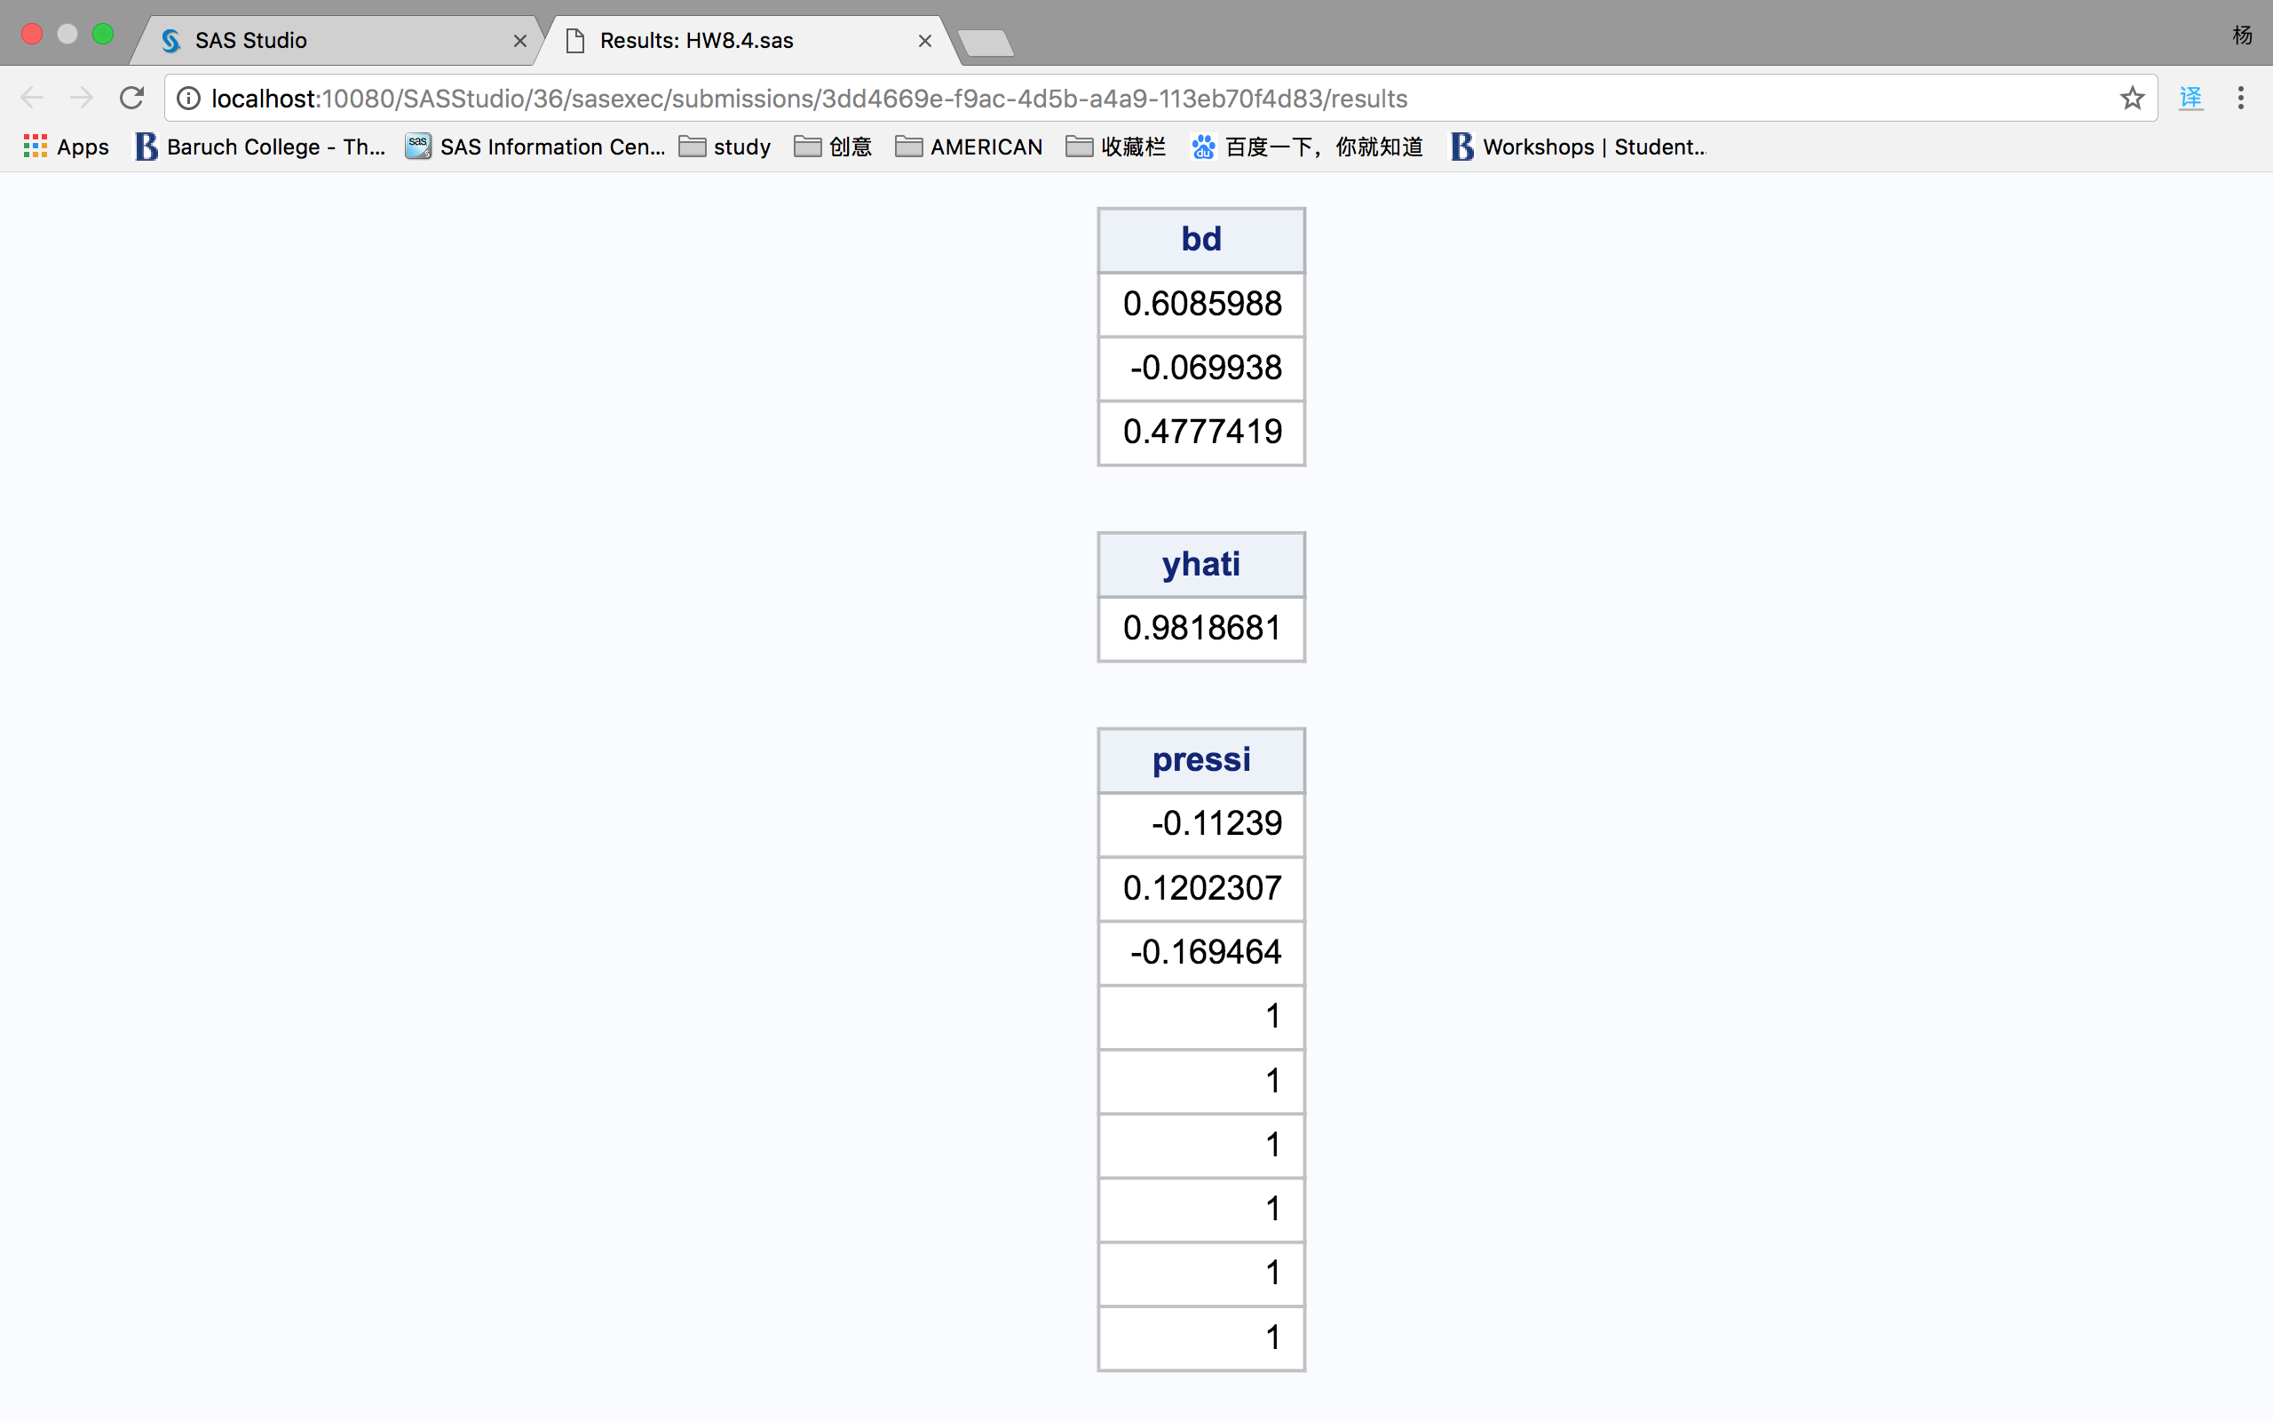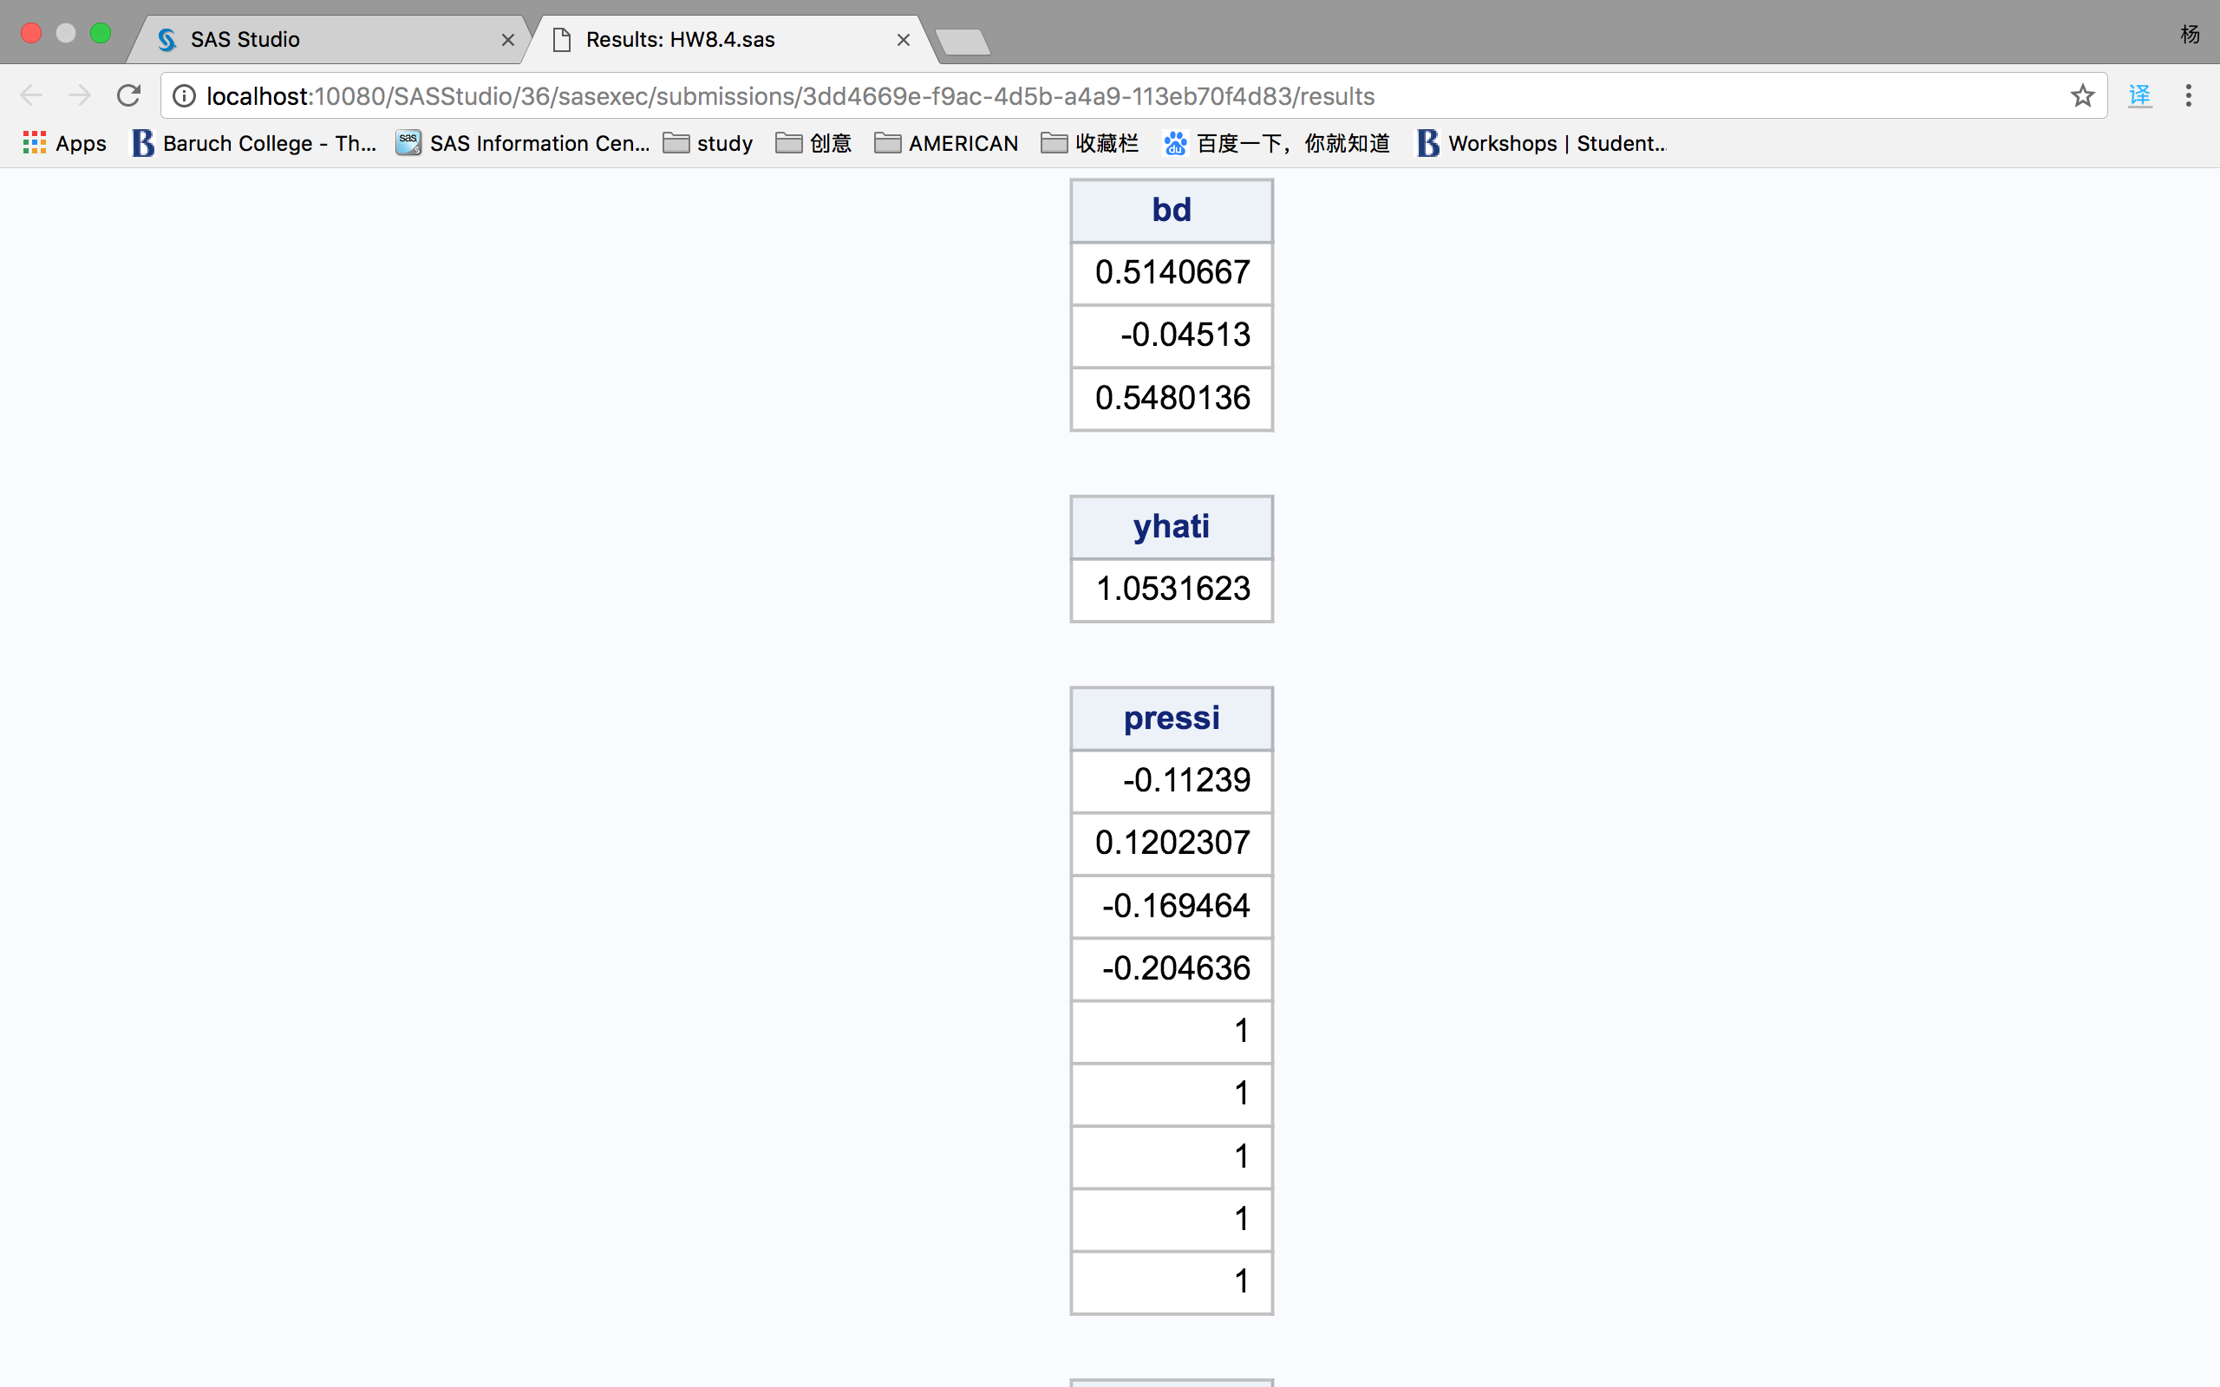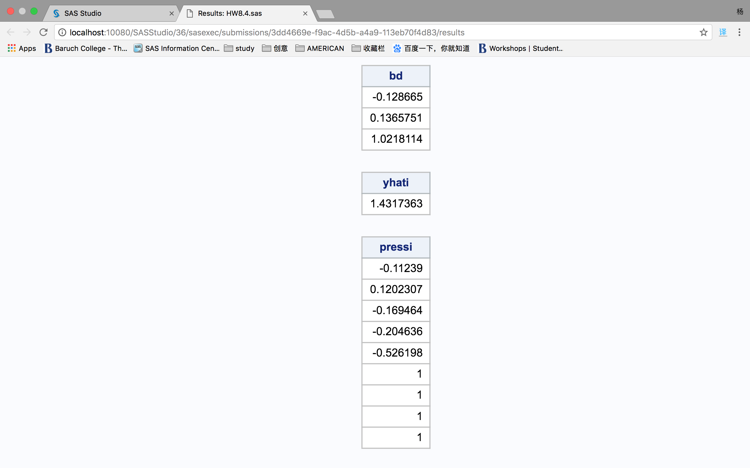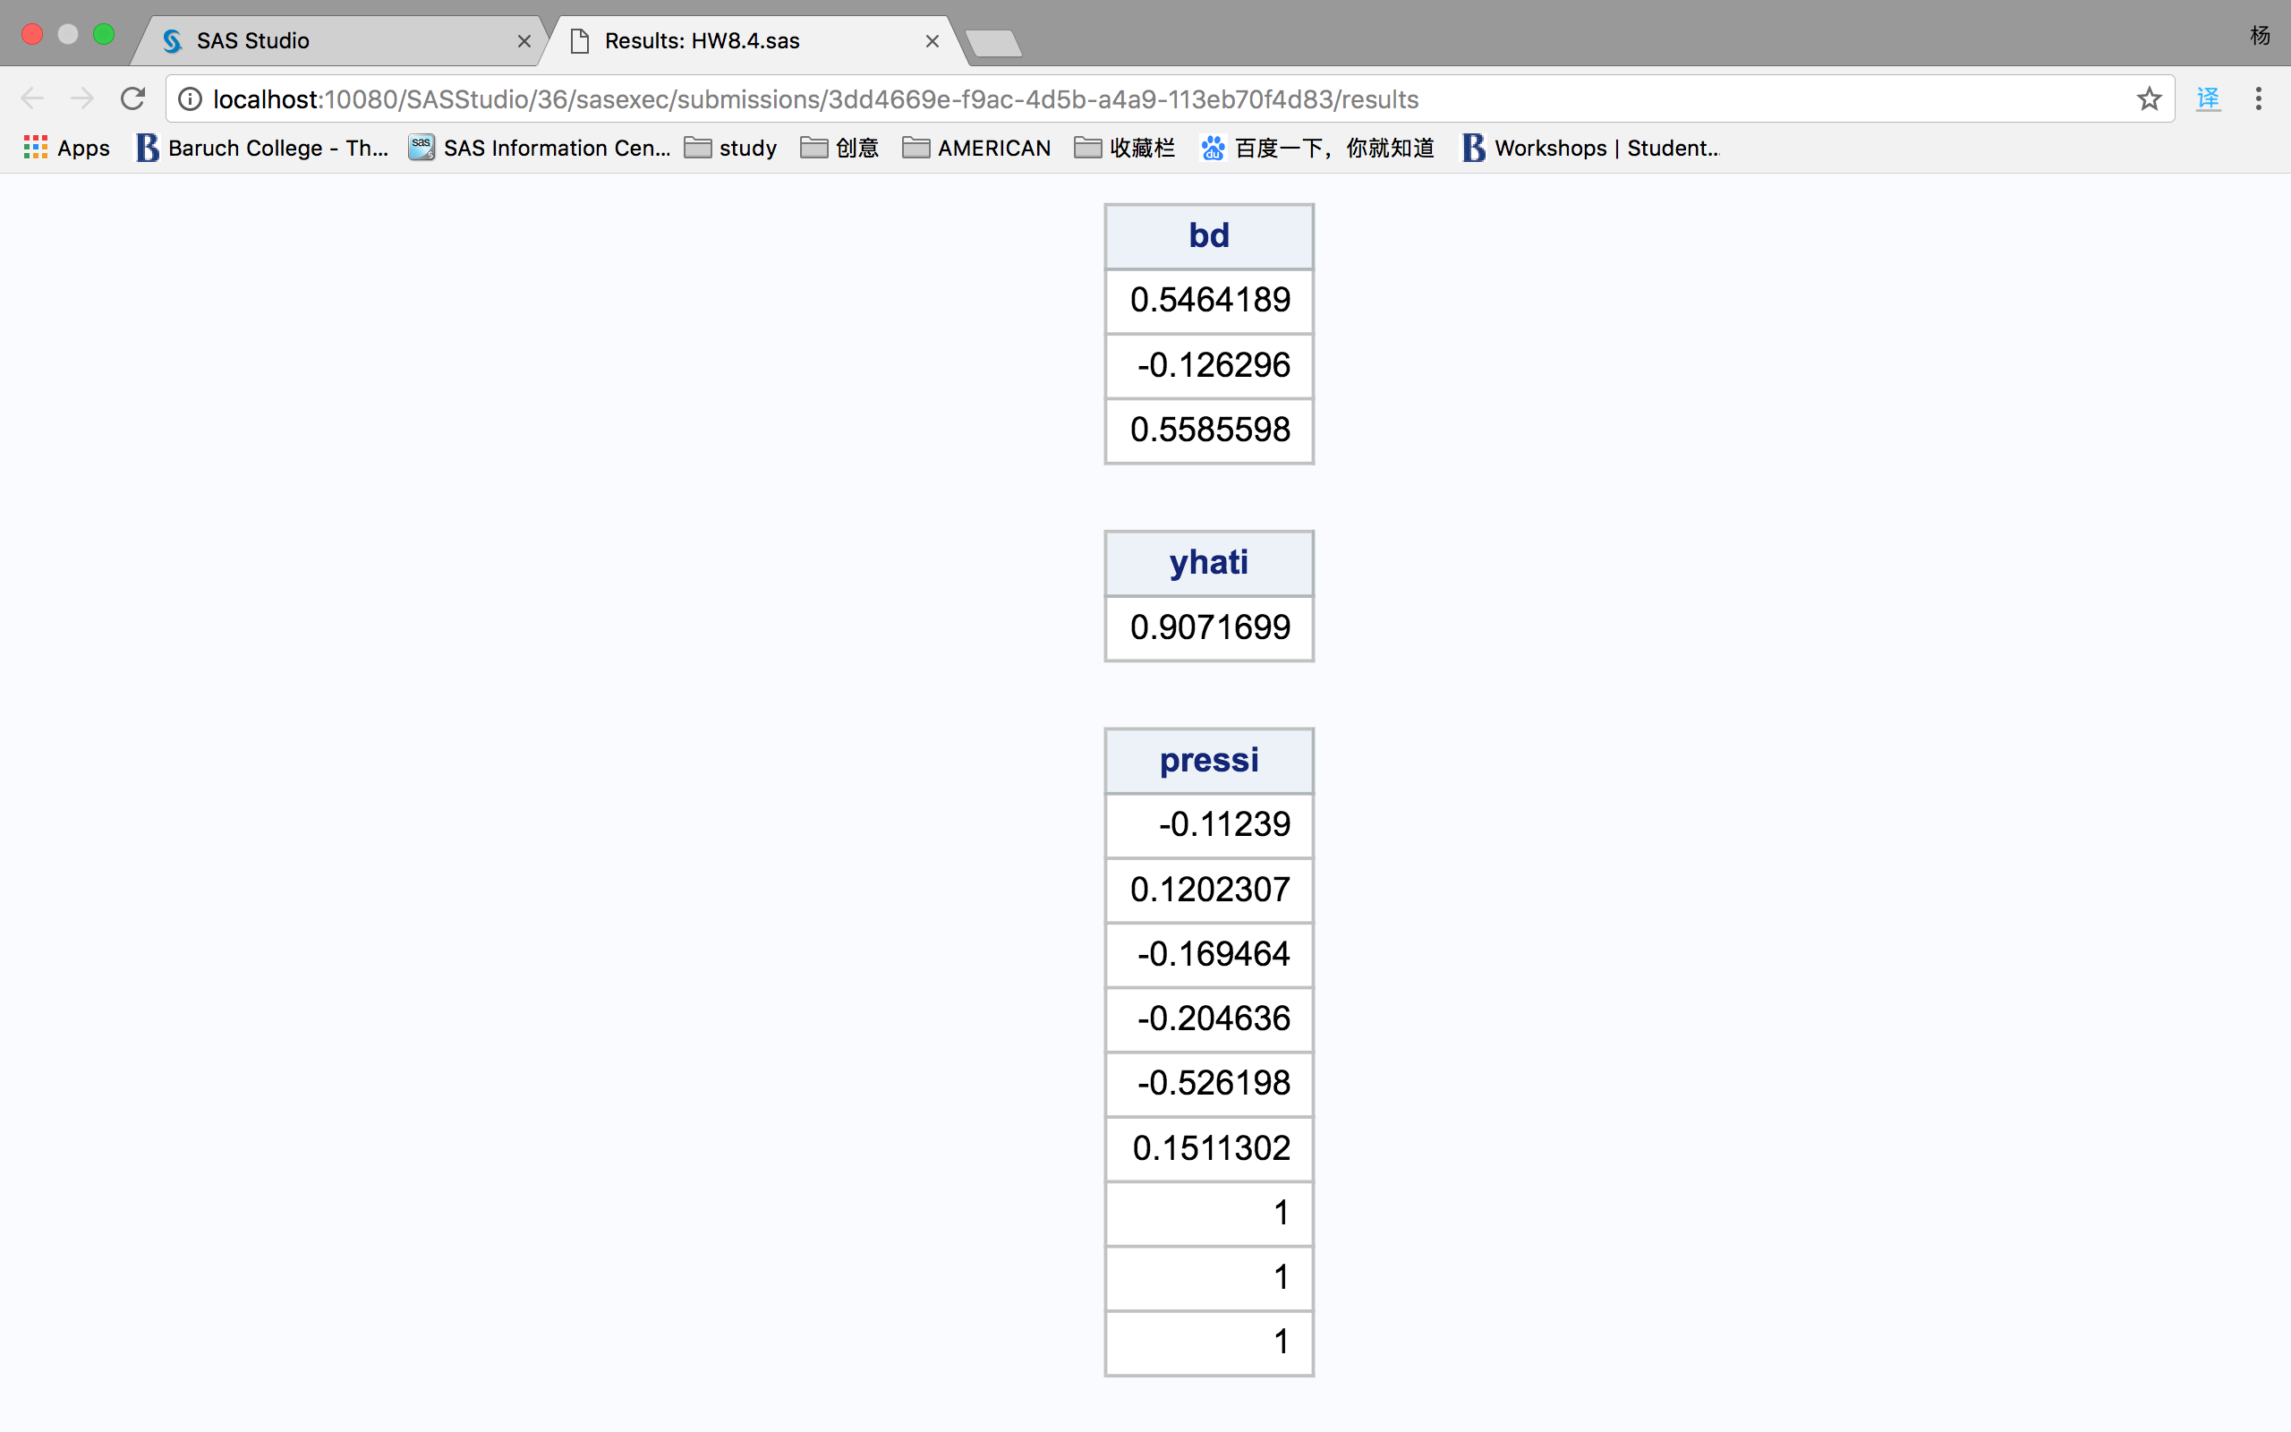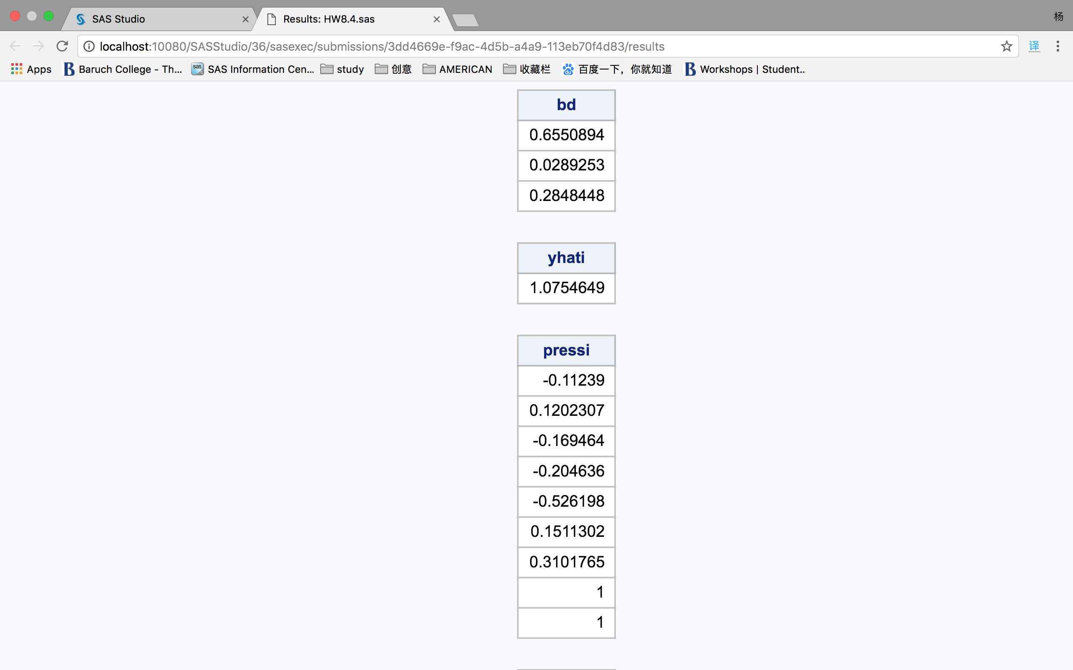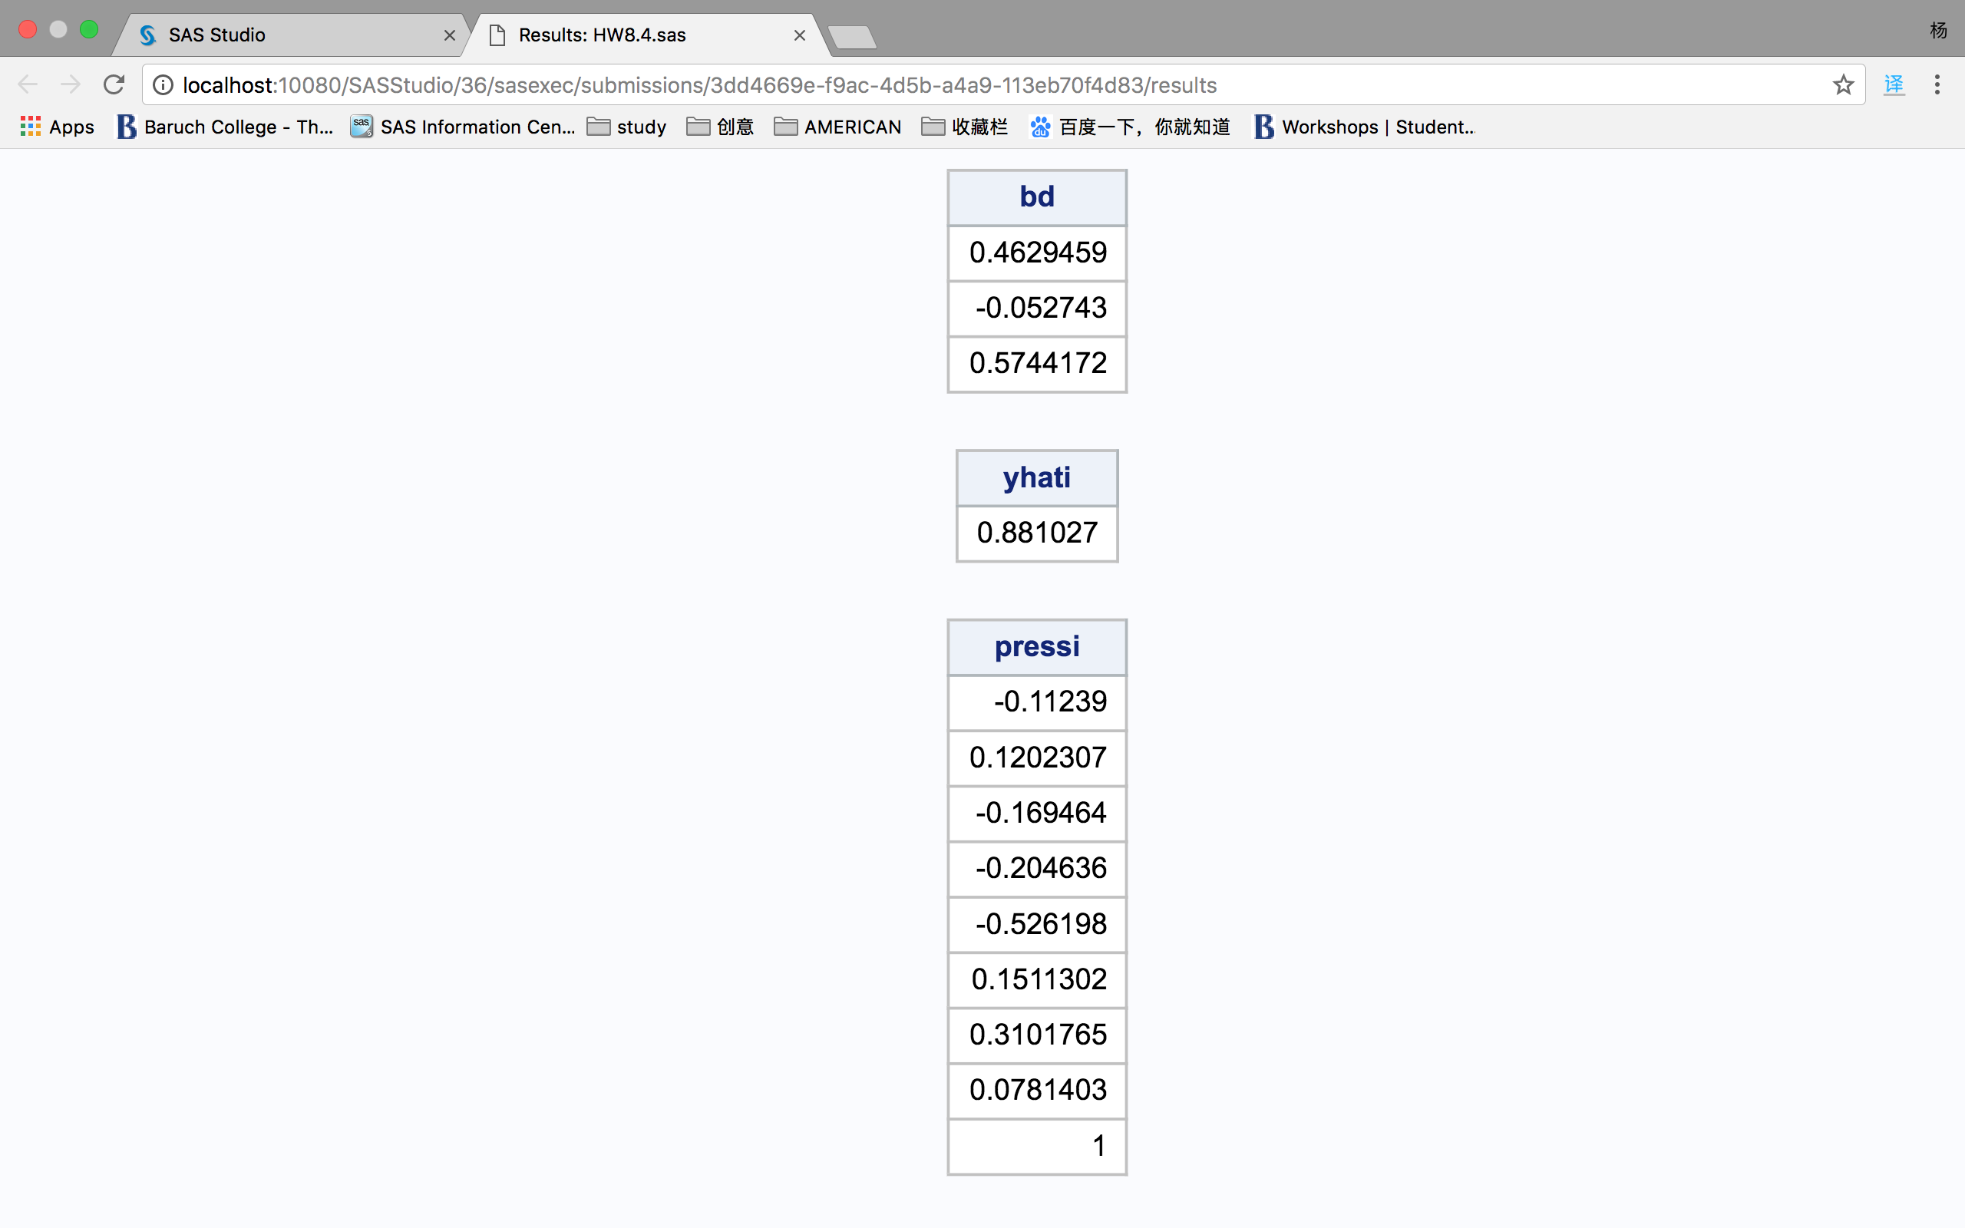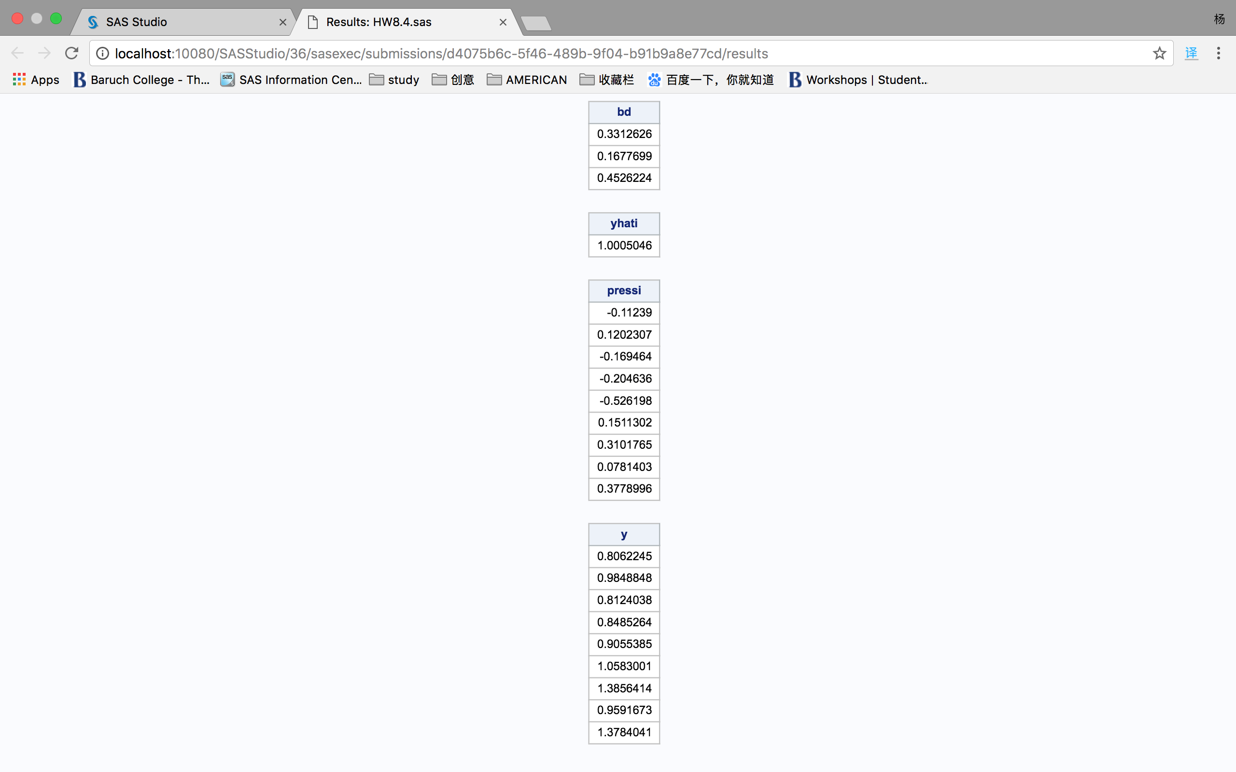

5. Cook’s D

(a).

Cook's D measures the influence of one point on others. Cook's distance is "an aggregate influence measure, showing the effect of the ith case on all *n* fitted values." For the first case, i=1, compute  for all n cases, but without the first case in the fitting. Take the sum of the squares of the resulting residuals and divide by the MSE times p. Do this for i=2, i=3, and so on, so each case gets it's own Cook's D measure:

Di = .

The following computational short-cut for DFITS has an illuminating interpretation,

Di = .

For the ith case, Di is the multiple of it's studentized deleted residual value, ti, and a term which will be very large when the ith case has high leverage. It will have high leverage when hi,i is close to 1, and in that case the denominator will be close to zero, "blowing up" the ratio.

(b). By the 4/n rules, there are 9 observations in the subset, so 4/n is 0.44444. Comparing to the computed Cook’s distance, there is only one point 0.84, larger than the 4/n criteria.



**Chapter 6. Analysis of a Fitted Model**

Our best regression model so far is the model with natural log transformation of y and other variables x1, x2, x5, x6, x7 and x9.

The model used now is lny regress on ln1, ln2, ln5, ln6, ln7 and ln9.

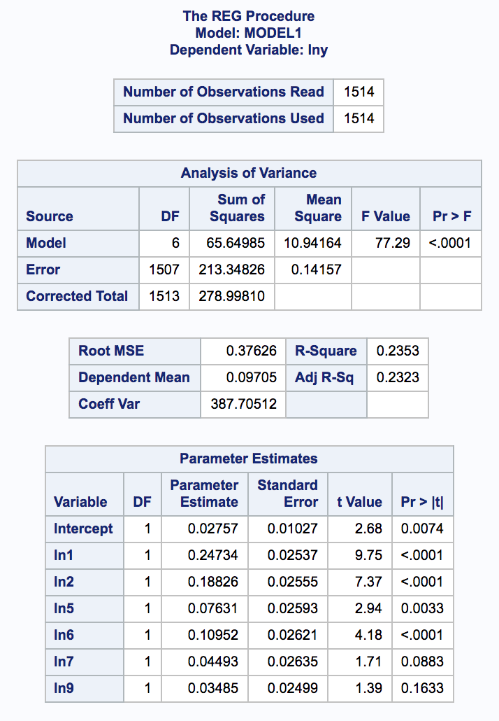

1. Analysis of Output

(a) The t-tests

For the partial slope for the first variable: ln1,

we use t-tests to test the following hypothesis:

H0: =0

H1: ≠0

Test statistic: t-stat =  = 0.24734/0.02537 = 9.75

Rejection region: |t-stat| > t-critical value, α=0.05

t-critical value with 6 d.f. = 2.447

Conclusion: null hypothesis is rejected,

because the |t-stat| = 9.75 greater than the t-critical value of 2.447.

Same hypothesis and t-tests are also performed for the rest of parameters in the model.

The results of the tests are that the true partial slope for variables ln1, ln2, ln5 and ln6 are not equal to 0. However, as partial slopes, the collinearity is obviously affecting the t-tests. Those variables with larger p-value may also have significant control on the y variable.

(b) The F-test

H0: = = === = 0

H1: ≠0 for at least one value of j

Test statistic: F-stat =  = (65.64985/6)/(213.34826/1506)= 77.2356 [p=k+1=6+1, here]

Rejection region: F-stat > F-critical value (p-1= 6 df, n-p=1506 df, α=0.05)

Conclusion: the null hypothesis is rejected

because the F-stat = 77.2356 is greater than the F-critical value.

(c) The -equation

lny =0.24734*ln1+0.18826*ln2+0.07631*ln5+0.10952*ln6+0.04493*ln7+0.03485*ln9

Here, our : lny is an unbiased estimator of Yx, so E(lny) is equal to the population average of ln(Y). The E(Yx) is the expect value of random variable y or the population average given certain level of x.

2. R-square

(a) The value of R-square is 0.2353.

(b) R-square = SST-SSE/SST = SSR/SST = 65.64985/278.99810 = 0.2353.

(c) The R-square value of 0.2353 is often called the “coefficient of determination”. We may interpret R2 as the proportionate reduction of total variation associated with the use of the predictor variable X. When we have no knowledge of ln1, ln2, ln5, ln6, ln7 and ln9, then a measure of the uncertainty in the sample lny is SST, the sum of the square deviations from ****. When we do know the value of ln1~9 and have fitted a regression model, then a measure of the remaining uncertainty in the lny is SSE, the sum of squared deviations from . Knowing the x-values has reduced the uncertainty by a total amount of SST-SSE = SSR. As a proportion, this reduction is

(SST-SSE)/SST = SSR/SST = R2.

(d) In naïve way, we can say 23.53% of the variation in lny explained by the introduction of ln1, ln2, ln5, ln6, ln7 and ln9 into our model.

3. Adjusted R-square

(a) The value of the adjusted R-square is 0.2323.

(b) It was computed by the formula:

adj-R2 = [SST/(n-1) - SSE/(n-k-1)] / [SST/(n-1)] [Here, k=6]

= .

(c) The adjusted R2 has a surprisingly clear and proper interpretation: it is the proportion by which knowledge of X reduces the sample variance**.** Here, the adjusted R-square was 0.2323. This means that knowing the ln1, ln2, ln5, ln6, ln7 and ln9 reduced the sample variance of the lny by 23.23%.

4. The *Partial* Regression Coefficients

(a) one variable

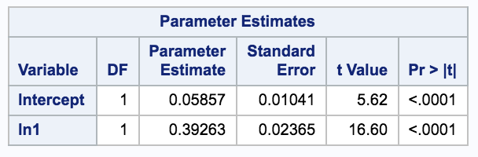

six variables



(b) Step 1: regress lny on (ln2 ln5 ln6 ln7 ln9) and save the residuals.

Step 2: regress ln1 on (ln2 ln5 ln6 ln7 ln9) and save the residuals.

Step 3: regress the residuals from Step 1 on the residuals from Step 2.

Step 4: rejoice, as Step 3 has indeed produced the partial coefficient of ln1.

(c)

In (b), Step 1 computes res_yother, the residuals from regressing lny on ln2 ln5 ln6 ln7 and ln9, Step2 computes res_x1other, the residuals from regressing ln1 on ln2 ln5 ln6 ln7 and ln9, Step 3, regress res_yother on res_x1other, which is the regression of y on ln2 ln5 ln6 ln7 and ln9 after having swept out all other x variables except ln1. Note that tortured coefficient matches that found for ln1 by the multiple regression model, 0.24734.

(d). Following SAS code is used to get the partial slope for ln1 and the output is provided.

**proc** **reg** data =rrdl;

model lny=ln2 ln5 ln6 ln7 ln9;

output out=res1 r=res_yother;

**run**;

**proc** **reg** data =rrdl;

model ln1=ln2 ln5 ln6 ln7 ln9;

output out=res2 r=res_x1other;

**run**;

**data** ress;

merge res1(keep=res_yother) res2(keep=res_x1other);

**run**;

**proc** **reg** data=ress;

title "Regression of res_yother on res_x1other";

model res_yother =res_x1other;

**run**;

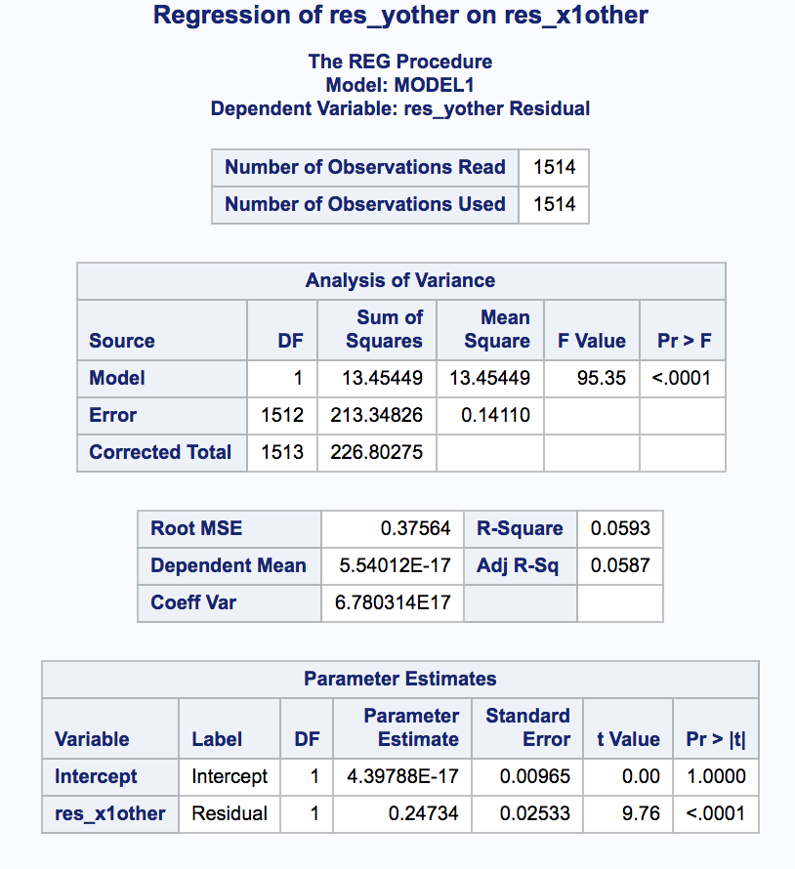

(e)

Step 1: regress lny on ln1 ln2 ln5 ln6 ln7 ln9 and save the SSE.

Step 2: regress lny on ln1 and save the SSE.

Step 3: divide the difference between SSE from Step1 and 2 by the SSE in step2

Step 4: rejoice, as Step 3 has indeed produced partial R2 of ln1.

In steps above, Step 1 computes SSE(full), the SSE from regressing lny on ln1 ln2 ln5 ln6 ln7 and ln9, Step2 computes SSE(reduced), the SSE from regressing lny on ln1, Step 3, divide the difference between SSE(full) and SSE(reduced), which gives us the proportion of variation explained by ln2~9 that cannot be explained by ln1.

5. Model Diagnostics

(a)

Cook's D measures the influence of one point on others. Cook's distance is "an aggregate influence measure, showing the effect of the ith case on all *n* fitted values." For the first case, i=1, compute  for all n cases, but without the first case in the fitting. Take the sum of the squares of the resulting residuals and divide by the MSE times p. Do this for i=2, i=3, and so on, so each case gets it's own Cook's D measure:

Di = .

The following computational short-cut for DFITS has an illuminating interpretation,

Di = .

For the ith case, Di is the multiple of it's studentized deleted residual value, ti, and a term which will be very large when the ith case has high leverage. It will have high leverage when hi,i is close to 1, and in that case the denominator will be close to zero, "blowing up" the ratio.

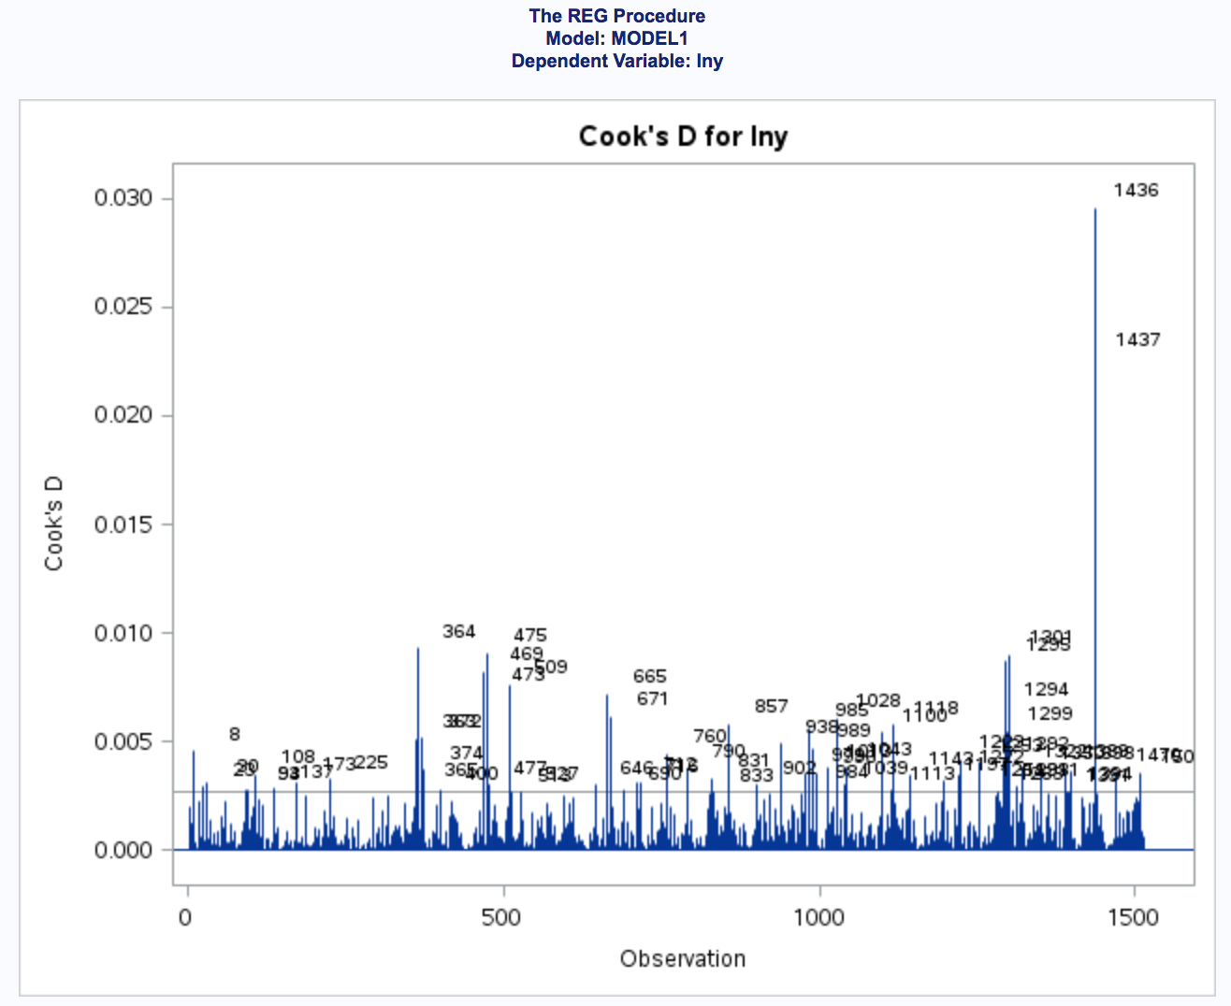

**Chapter 7*.* Models for Autocorrelation**

1. Handling Random Walks

As the data we use is the daily risk range for stock JWN, it is some kind of time series data. Random walk is a natural property of our data. A simple or multiple regression model designed to deal with autocorrelation are not intended to handle random walks: we have to take an appropriate transformation. After that, we need to apply a statistical model designed to handle autocorrelations with random walks.

Here, we have already used a natural log transformation of all the X variables, which is consistent with the use of the log-Normal distribution to model stock prices.

1. The First-Order Autoregressive Model

The statistical workhorse for dealing with autocorrelation in a time series is the first-order autoregressive model*,* often denoted AR(1).

Yt = + xt + εt,

where,

εt = ρ εt-1 + ut,

and ut is now the independent and identically distributed random innovations. That is, μt replaces εt as denoting the impact of independent random variables, or *news*.

In the above equation, ρ denotes the first-order *autocorrelation parameter* and its absolute value is constrained to be less than 1. If we allow ρ=1, we have a *random walk* and a drastic transformation is called for, such as percentage change.

1. The Durbin-Watson Test

The Durbin-Watson (D-W) test is the primary test used to detect the presence of autocorrelation. The null hypothesis for the D-W test is that ρ=0 in a first-order AR model. The test D-W statistic, D, is a marvel of ingenuity:

D = .

This statistic is beautifully designed to pick up positive autocorrelation, which describes the situation in which those residuals which are close together in time are also close together in value. When e­t and et-1 tend to be similar in value, then the sum of their squared differences across t will be small, particularly in comparison to the sum of et2 across t. Under the null hypothesis, the expected value of D is about 2, but the distribution is in fact quite complicated and it is difficult to pin down the rejection region. As a rule of thumb, reject the null if D<1.6 or D>2.4. SAS provides approximate p-values.

1. Test the model on the data

Basically, we have to also include the date as a variable into our model. Before, we have already got our best model, which is lny regress on ln1 ln2 ln5 ln6 ln7 ln9 (Natural log transformation on y, x1 x2 x5 x6 x7 x9). The second-order autoregressive model is not tested due to the Proc Autoreg function in SAS is not universally available.

The D-W test is included in the output, and regression summary follows. The D-W test statistic is 2.029, which is shown to be *near* 2.0 by the p-value. So the null hypothesis is not rejected. The ρ in our model may equal to 0, which means our model may not contain a random walk.

